Lương Mạnh Hòa – B21DCCN378

1. Determine requirements

* Define use cases and draw use case diagram in two levels: General level (>=20 use cases) and Level 1 (detail)
  + General level (>=20 use cases)

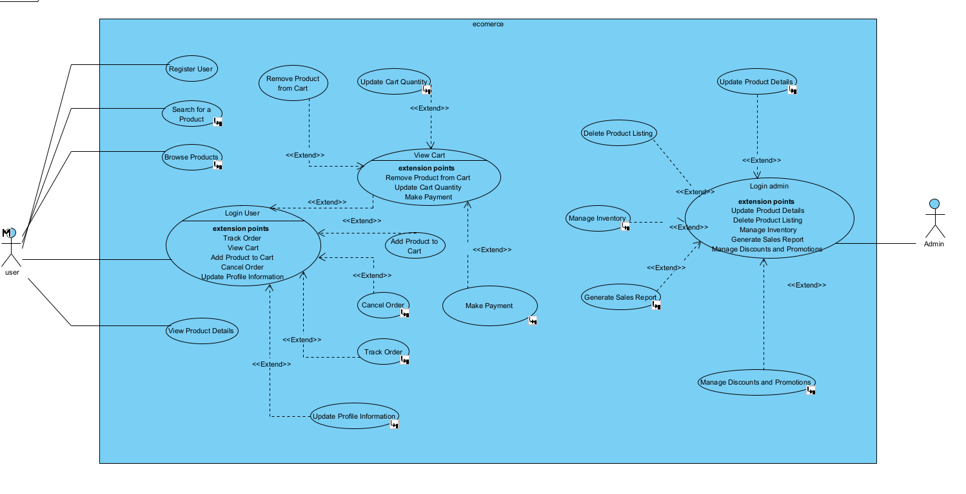

* + Level 1 (detail)

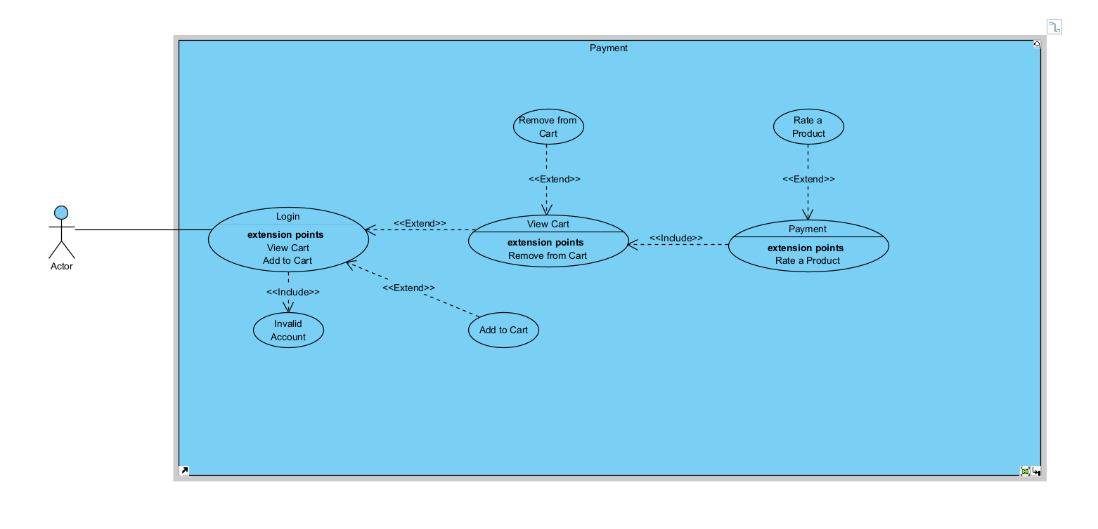

* Write 30 scenarios and 30 user stories + acceptance criteria
  + 30 scenarios

|  |  |  |  |  |
| --- | --- | --- | --- | --- |
| Use Case ID: | UC-1 | | | |
| Use Case Name: | Register User | | | |
| Created By: | Quan | | Last Updated By: | Quan |
| Date Created: | 16/11/2024 | | Date Last Updated: | 16/11/2024 |
| Actor: | | Customer | | |
| Description: | | The customer registers for an account to make purchases. | | |
| Preconditions: | | Customer has no account. | | |
| Postconditions: | | Account is created, and the customer is logged in. | | |
| Priority: | | High | | |
| Frequency of Use: | | Common | | |
| Normal Course of Events: | | 1. Customer navigates to the "Register" page. 2. Customer enters personal details and creates a password. 3. System creates the account and logs the customer in. | | |
| Alternative Courses: | | If the email is already registered, prompt the customer to log in. | | |
| Exceptions: | | None | | |
| Includes: | | None | | |
| Special Requirements: | | None | | |
| Assumptions: | | Customer provides valid information. | | |
| Notes and Issues: | | None | | |

|  |  |  |  |  |
| --- | --- | --- | --- | --- |
| Use Case ID: | UC-2 | | | |
| Use Case Name: | Login | | | |
| Created By: | Quan | | Last Updated By: | Quan |
| Date Created: | 16/11/2024 | | Date Last Updated: | 16/11/2024 |
| Actor: | | Customer | | |
| Description: | | The customer logs into their account to make purchases. | | |
| Preconditions: | | Customer has an existing account. | | |
| Postconditions: | | Customer is logged in and can make purchases. | | |
| Priority: | | High | | |
| Frequency of Use: | | Common | | |
| Normal Course of Events: | | 1. Customer navigates to the login page. 2. Customer enters email and password. 3. System authenticates the credentials and logs the customer in. | | |
| Alternative Courses: | | If the credentials are incorrect, the system prompts the user to try again. | | |
| Exceptions: | | None | | |
| Includes: | | None | | |
| Special Requirements: | | None | | |
| Assumptions: | | Customer knows their credentials. | | |
| Notes and Issues: | | None | | |

|  |  |  |  |  |
| --- | --- | --- | --- | --- |
| Use Case ID: | UC-3 | | | |
| Use Case Name: | Browse Products | | | |
| Created By: | Quan | |  |  |
| Date Created: | 16/11/2024 | |  |  |
| Actor: | | Customer | | |
| Description: | | The customer browses through the available products. | | |
| Preconditions: | | Customer is logged in. | | |
| Postconditions: | | Customer views a list of products available for purchase. | | |
| Priority: | | High | | |
| Frequency of Use: | | Common | | |
| Normal Course of Events: | | 1. Customer selects a category (e.g., electronics, books). 2. System displays a list of products in the chosen category. | | |
| Alternative Courses: | | None | | |
| Exceptions: | | None | | |
| Includes: | | None | | |
| Special Requirements: | | None | | |
| Assumptions: | | Product listings are up-to-date. | | |
| Notes and Issues: | | None | | |

|  |  |  |  |  |
| --- | --- | --- | --- | --- |
| Use Case ID: | UC-4 | | | |
| Use Case Name: | Search for a Product | | | |
| Created By: | Quan | | Last Updated By: | Quan |
| Date Created: | 16/11/2024 | | Date Last Updated: | 16/11/2024 |
| Actor: | | Customer | | |
| Description: | | The customer searches for a specific product by name or category. | | |
| Preconditions: | | Customer is logged in. | | |
| Postconditions: | | Customer sees a list of products that match the search query. | | |
| Priority: | | Medium | | |
| Frequency of Use: | | Common | | |
| Normal Course of Events: | | 1. Customer enters a keyword or category in the search bar. 2. System displays relevant search results. | | |
| Alternative Courses: | | If no results are found, the system suggests related products. | | |
| Exceptions: | | None | | |
| Includes: | | None | | |
| Special Requirements: | | None | | |
| Assumptions: | | Search terms are relevant and spelled correctly. | | |
| Notes and Issues: | | None | | |

|  |  |  |  |  |
| --- | --- | --- | --- | --- |
| Use Case ID: | UC-5 | | | |
| Use Case Name: | Add Product to Cart | | | |
| Created By: | Quan | | Last Updated By: | Quan |
| Date Created: | 16/11/2024 | | Date Last Updated: | 16/11/2024 |
| Actor: | | Customer | | |
| Description: | | The customer adds a product to their shopping cart. | | |
| Preconditions: | | Customer has selected a product. | | |
| Postconditions: | | Product is added to the shopping cart. | | |
| Priority: | | High | | |
| Frequency of Use: | | Common | | |
| Normal Course of Events: | | 1. Customer selects a product to view its details. 2. Customer clicks "Add to Cart." 3. System adds the product to the cart. | | |
| Alternative Courses: | | None | | |
| Exceptions: | | None | | |
| Includes: | | None | | |
| Special Requirements: | | None | | |
| Assumptions: | | Product is available in stock. | | |
| Notes and Issues: | | None | | |

|  |  |  |  |  |
| --- | --- | --- | --- | --- |
| Use Case ID: | UC-6 | | | |
| Use Case Name: | View Cart | | | |
| Created By: | Quan | | Last Updated By: | Quan |
| Date Created: | 16/11/2024 | | Date Last Updated: | 16/11/2024 |
| Actor: | | Customer | | |
| Description: | | The customer views the products in their shopping cart. | | |
| Preconditions: | | Customer has added products to the cart. | | |
| Postconditions: | | Customer sees the list of products in the cart. | | |
| Priority: | | High | | |
| Frequency of Use: | | Common | | |
| Normal Course of Events: | | 1. Customer clicks on the "Cart" icon. 2. System displays the contents of the cart with product details. | | |
| Alternative Courses: | | None | | |
| Exceptions: | | None | | |
| Includes: | | None | | |
| Special Requirements: | | None | | |
| Assumptions: | | The cart is accurately updated. | | |
| Notes and Issues: | | None | | |

|  |  |  |  |  |
| --- | --- | --- | --- | --- |
| Use Case ID: | UC-7 | | | |
| Use Case Name: | Remove Product from Cart | | | |
| Created By: | Quan | | Last Updated By: | Quan |
| Date Created: | 16/11/2024 | | Date Last Updated: | 16/11/2024 |
| Actor: | | Customer | | |
| Description: | | The customer removes a product from their shopping cart. | | |
| Preconditions: | | Customer has added products to the cart. | | |
| Postconditions: | | Product is removed from the cart. | | |
| Priority: | | Medium | | |
| Frequency of Use: | | Occasionally | | |
| Normal Course of Events: | | 1. Customer clicks the "Remove" button next to the product. 2. System removes the product from the cart. | | |
| Alternative Courses: | | None | | |
| Exceptions: | | None | | |
| Includes: | | None | | |
| Special Requirements: | | None | | |
| Assumptions: | | The customer wishes to change their cart contents. | | |
| Notes and Issues: | | None | | |

|  |  |  |  |  |
| --- | --- | --- | --- | --- |
| Use Case ID: | UC-8 | | | |
| Use Case Name: | Update Cart Quantity | | | |
| Created By: | Quan | | Last Updated By: | Quan |
| Date Created: | 16/11/2024 | | Date Last Updated: | 16/11/2024 |
| Actor: | | Customer | | |
| Description: | | The customer changes the quantity of an item in their cart. | | |
| Preconditions: | | Customer has added products to the cart. | | |
| Postconditions: | | The quantity of the product in the cart is updated. | | |
| Priority: | | Medium | | |
| Frequency of Use: | | Occasionally | | |
| Normal Course of Events: | | 1. Customer clicks the quantity box next to the product. 2. Customer updates the quantity. 3. System updates the cart with the new quantity. | | |
| Alternative Courses: | | None | | |
| Exceptions: | | None | | |
| Includes: | | None | | |
| Special Requirements: | | None | | |
| Assumptions: | | Product availability is sufficient for the requested quantity. | | |
| Notes and Issues: | | None | | |

|  |  |  |  |  |
| --- | --- | --- | --- | --- |
| Use Case ID: | UC-9 | | | |
| Use Case Name: | Checkout | | | |
| Created By: | Quan | | Last Updated By: | Quan |
| Date Created: | 16/11/2024 | | Date Last Updated: | 16/11/2024 |
| Actor: | | Customer | | |
| Description: | | The customer proceeds to checkout to complete their purchase. | | |
| Preconditions: | | Customer has items in their cart. | | |
| Postconditions: | | Customer enters payment details, and an order is created. | | |
| Priority: | | High | | |
| Frequency of Use: | | Common | | |
| Normal Course of Events: | | 1. Customer clicks "Proceed to Checkout." 2. System prompts the customer to enter shipping and payment details. 3. Customer submits the order. 4. System processes the payment and confirms the order. | | |
| Alternative Courses: | | If payment fails, the system prompts the customer to try again. | | |
| Exceptions: | | None | | |
| Includes: | | None | | |
| Special Requirements: | | None | | |
| Assumptions: | | Payment information is valid and complete. | | |
| Notes and Issues: | | None | | |

|  |  |  |  |  |
| --- | --- | --- | --- | --- |
| Use Case ID: | UC-10 | | | |
| Use Case Name: | Make Payment | | | |
| Created By: | Quan | | Last Updated By: | Quan |
| Date Created: | 16/11/2024 | | Date Last Updated: | 16/11/2024 |
| Actor: | | Customer | | |
| Description: | | The customer enters payment details to complete the purchase. | | |
| Preconditions: | | Customer has reached the checkout stage. | | |
| Postconditions: | | Payment is processed, and the order is confirmed. | | |
| Priority: | | High | | |
| Frequency of Use: | | Common | | |
| Normal Course of Events: | | 1. Customer selects a payment method (credit card, PayPal, etc.). 2. Customer enters payment details. 3. System processes the payment and confirms the transaction. | | |
| Alternative Courses: | | If the payment is declined, the customer is asked to retry or choose another method. | | |
| Exceptions: | | None | | |
| Includes: | | None | | |
| Special Requirements: | | None | | |
| Assumptions: | | Payment system is functioning properly. | | |
| Notes and Issues: | | None | | |

|  |  |  |  |  |
| --- | --- | --- | --- | --- |
| Use Case ID: | UC-11 | | | |
| Use Case Name: | Track Order | | | |
| Created By: | Quan | | Last Updated By: | Quan |
| Date Created: | 16/11/2024 | | Date Last Updated: | 16/11/2024 |
| Actor: | | Customer | | |
| Description: | | The customer tracks their order status after it has been shipped. | | |
| Preconditions: | | Order has been shipped. | | |
| Postconditions: | | Customer is provided with the current status of their order. | | |
| Priority: | | Medium | | |
| Frequency of Use: | | Occasionally | | |
| Normal Course of Events: | | 1. Customer navigates to the "Order History" page. 2. Customer selects the order they wish to track. 3. System provides the shipping status and tracking details. | | |
| Alternative Courses: | | None | | |
| Exceptions: | | None | | |
| Includes: | | None | | |
| Special Requirements: | | None | | |
| Assumptions: | | Shipping service updates tracking information. | | |
| Notes and Issues: | | None | | |

|  |  |  |  |  |
| --- | --- | --- | --- | --- |
| Use Case ID: | UC-12 | | | |
| Use Case Name: | Cancel Order | | | |
| Created By: | Quan | | Last Updated By: | Quan |
| Date Created: | 16/11/2024 | | Date Last Updated: | 16/11/2024 |
| Actor: | | Customer | | |
| Description: | | The customer cancels an order before it has been shipped. | | |
| Preconditions: | | Order has been placed but not yet shipped. | | |
| Postconditions: | | Order is canceled, and any payments are refunded. | | |
| Priority: | | Medium | | |
| Frequency of Use: | | Occasionally | | |
| Normal Course of Events: | | 1. Customer navigates to the order details and selects "Cancel Order." 2. System confirms the cancellation and processes a refund if applicable. | | |
| Alternative Courses: | | If the order has already been shipped, cancellation is not possible. | | |
| Exceptions: | | None | | |
| Includes: | | None | | |
| Special Requirements: | | None | | |
| Assumptions: | | Cancellation policy is clear and enforced. | | |
| Notes and Issues: | | None | | |

|  |  |  |  |  |
| --- | --- | --- | --- | --- |
| Use Case ID: | UC-13 | | | |
| Use Case Name: | Return a Product | | | |
| Created By: | Quan | | Last Updated By: | Quan |
| Date Created: | 16/11/2024 | | Date Last Updated: | 16/11/2024 |
| Actor: | | Customer | | |
| Description: | | The customer returns a product they have received. | | |
| Preconditions: | | Product return policy is still valid. | | |
| Postconditions: | | Product return is processed, and refund or replacement is initiated. | | |
| Priority: | | Medium | | |
| Frequency of Use: | | Occasionally | | |
| Normal Course of Events: | | 1. Customer navigates to "Order History" and selects "Return" for the product. 2. System provides return instructions and updates the return status. | | |
| Alternative Courses: | | If the return policy has expired, return is denied. | | |
| Exceptions: | | None | | |
| Includes: | | None | | |
| Special Requirements: | | None | | |
| Assumptions: | | Return policy is clear and followed. | | |
| Notes and Issues: | | None | | |

|  |  |  |  |  |
| --- | --- | --- | --- | --- |
| Use Case ID: | UC-14 | | | |
| Use Case Name: | Leave a Product Review | | | |
| Created By: | Quan | | Last Updated By: | Quan |
| Date Created: | 16/11/2024 | | Date Last Updated: | 16/11/2024 |
| Actor: | | Customer | | |
| Description: | | The customer leaves a review and rating for a purchased product. | | |
| Preconditions: | | Customer has purchased the product. | | |
| Postconditions: | | Review is submitted and visible on the product page. | | |
| Priority: | | Medium | | |
| Frequency of Use: | | Occasionally | | |
| Normal Course of Events: | | 1. Customer navigates to the product page. 2. Customer selects "Write a Review" and provides a rating and comments. 3. System submits the review and displays it on the product page. | | |
| Alternative Courses: | | None | | |
| Exceptions: | | None | | |
| Includes: | | None | | |
| Special Requirements: | | None | | |
| Assumptions: | | Review system is functioning properly. | | |
| Notes and Issues: | | None | | |

|  |  |  |  |  |
| --- | --- | --- | --- | --- |
| Use Case ID: | UC-15 | | | |
| Use Case Name: | View Product Details | | | |
| Created By: | Quan | | Last Updated By: | Quan |
| Date Created: | 16/11/2024 | | Date Last Updated: | 16/11/2024 |
| Actor: | | Customer | | |
| Description: | | The customer views the detailed information about a product. | | |
| Preconditions: | | Customer has selected a product. | | |
| Postconditions: | | Customer views detailed product information. | | |
| Priority: | | High | | |
| Frequency of Use: | | Common | | |
| Normal Course of Events: | | 1. Customer clicks on a product. 2. System displays product details such as description, price, images, and specifications. | | |
| Alternative Courses: | | None | | |
| Exceptions: | | None | | |
| Includes: | | None | | |
| Special Requirements: | | None | | |
| Assumptions: | | Product details are accurate and complete. | | |
| Notes and Issues: | | None | | |

|  |  |  |  |  |
| --- | --- | --- | --- | --- |
| Use Case ID: | UC-16 | | | |
| Use Case Name: | Cancel Order | | | |
| Created By: | Quan | | Last Updated By: | Quan |
| Date Created: | 16/11/2024 | | Date Last Updated: | 16/11/2024 |
| Actor: | | Customer | | |
| Description: | | The customer cancels an order before it has been shipped. | | |
| Preconditions: | | Order has been placed but not yet shipped. | | |
| Postconditions: | | Order is canceled, and any payments are refunded. | | |
| Priority: | | Medium | | |
| Frequency of Use: | | Occasionally | | |
| Normal Course of Events: | | 1. Customer navigates to the order details and selects "Cancel Order." 2. System confirms the cancellation and processes a refund if applicable. | | |
| Alternative Courses: | | If the order has already been shipped, cancellation is not possible. | | |
| Exceptions: | | None | | |
| Includes: | | None | | |
| Special Requirements: | | None | | |
| Assumptions: | | Cancellation policy is clear and enforced. | | |
| Notes and Issues: | | None | | |

|  |  |  |  |  |
| --- | --- | --- | --- | --- |
| Use Case ID: | UC-17 | | | |
| Use Case Name: | Return a Product | | | |
| Created By: | Quan | | Last Updated By: | Quan |
| Date Created: | 16/11/2024 | | Date Last Updated: | 16/11/2024 |
| Actor: | | Customer | | |
| Description: | | The customer returns a product they have received. | | |
| Preconditions: | | Product return policy is still valid. | | |
| Postconditions: | | Product return is processed, and refund or replacement is initiated. | | |
| Priority: | | Medium | | |
| Frequency of Use: | | Occasionally | | |
| Normal Course of Events: | | 1. Customer navigates to "Order History" and selects "Return" for the product. 2. System provides return instructions and updates the return status. | | |
| Alternative Courses: | | If the return policy has expired, return is denied. | | |
| Exceptions: | | None | | |
| Includes: | | None | | |
| Special Requirements: | | None | | |
| Assumptions: | | Return policy is clear and followed. | | |
| Notes and Issues: | | None | | |

|  |  |  |  |  |
| --- | --- | --- | --- | --- |
| Use Case ID: | UC-18 | | | |
| Use Case Name: | Apply Coupon Code | | | |
| Created By: | Quan | | Last Updated By: | Quan |
| Date Created: | 16/11/2024 | | Date Last Updated: | 16/11/2024 |
| Actor: | | Customer | | |
| Description: | | The customer applies a discount coupon during checkout. | | |
| Preconditions: | | Customer has a valid coupon. | | |
| Postconditions: | | Discount is applied to the total price. | | |
| Priority: | | Medium | | |
| Frequency of Use: | | Occasionally | | |
| Normal Course of Events: | | 1. Customer enters the coupon code at checkout. 2. System validates the coupon and applies the discount. | | |
| Alternative Courses: | | If the coupon is invalid, the system displays an error message. | | |
| Exceptions: | | None | | |
| Includes: | | None | | |
| Special Requirements: | | None | | |
| Assumptions: | | Customer has a valid coupon code. | | |
| Notes and Issues: | | None | | |

|  |  |  |  |  |
| --- | --- | --- | --- | --- |
| Use Case ID: | UC-19 | | | |
| Use Case Name: | Track Order | | | |
| Created By: | Quan | | Last Updated By: | Quan |
| Date Created: | 16/11/2024 | | Date Last Updated: | 16/11/2024 |
| Actor: | | Customer | | |
| Description: | | The customer tracks the shipping status of their order. | | |
| Preconditions: | | Order has been shipped. | | |
| Postconditions: | | Customer receives updated tracking information. | | |
| Priority: | | Medium | | |
| Frequency of Use: | | Occasionally | | |
| Normal Course of Events: | | 1. Customer navigates to the "Order History" page. 2. Customer clicks "Track Order." 3. System provides the current shipping status and tracking number. | | |
| Alternative Courses: | | None | | |
| Exceptions: | | None | | |
| Includes: | | None | | |
| Special Requirements: | | None | | |
| Assumptions: | | Shipping service updates tracking details. | | |
| Notes and Issues: | | None | | |

|  |  |  |  |  |
| --- | --- | --- | --- | --- |
| Use Case ID: | UC-20 | | | |
| Use Case Name: | Update Profile Information | | | |
| Created By: | Quan | | Last Updated By: | Quan |
| Date Created: | 16/11/2024 | | Date Last Updated: | 16/11/2024 |
| Actor: | | Customer | | |
| Description: | | The customer updates their profile information, such as email or address. | | |
| Preconditions: | | Customer is logged in. | | |
| Postconditions: | | Customer's profile information is updated. | | |
| Priority: | | Medium | | |
| Frequency of Use: | | Occasionally | | |
| Normal Course of Events: | | 1. Customer navigates to "Profile" page. 2. Customer updates the desired fields (email, phone number, address). 3. System saves the updated information. | | |
| Alternative Courses: | | None | | |
| Exceptions: | | None | | |
| Includes: | | None | | |
| Special Requirements: | | None | | |
| Assumptions: | | Customer provides valid information. | | |
| Notes and Issues: | | None | | |

|  |  |  |  |  |
| --- | --- | --- | --- | --- |
| Use Case ID: | UC-21 | | | |
| Use Case Name: | View Order History | | | |
| Created By: | Quan | | Last Updated By: | Quan |
| Date Created: | 16/11/2024 | | Date Last Updated: | 16/11/2024 |
| Actor: | | Customer | | |
| Description: | | The customer views their previous orders. | | |
| Preconditions: | | Customer has made at least one order. | | |
| Postconditions: | | Customer can view the details of all their past orders. | | |
| Priority: | | Medium | | |
| Frequency of Use: | | Occasionally | | |
| Normal Course of Events: | | 1. Customer navigates to "Order History" page. 2. System displays a list of past orders, with details such as dates and items. | | |
| Alternative Courses: | | None | | |
| Exceptions: | | None | | |
| Includes: | | None | | |
| Special Requirements: | | None | | |
| Assumptions: | | Order history is correctly maintained. | | |
| Notes and Issues: | | None | | |

|  |  |  |  |  |
| --- | --- | --- | --- | --- |
| Use Case ID: | UC-22 | | | |
| Use Case Name: | Create New Product Listing | | | |
| Created By: | Quan | | Last Updated By: | Quan |
| Date Created: | 16/11/2024 | | Date Last Updated: | 16/11/2024 |
| Actor: | | Staff | | |
| Description: | | The staff adds a new product to the site. | | |
| Preconditions: | | Staff is logged in with appropriate privileges. | | |
| Postconditions: | | The new product is listed on the website. | | |
| Priority: | | High | | |
| Frequency of Use: | | Occasionally | | |
| Normal Course of Events: | | 1. Staff selects "Create New Product" from the admin dashboard. 2. Staff enters product details (name, price, description, images). 3. System saves the product and displays it on the site. | | |
| Alternative Courses: | | None | | |
| Exceptions: | | None | | |
| Includes: | | None | | |
| Special Requirements: | | None | | |
| Assumptions: | | Product information is accurate and complete. | | |
| Notes and Issues: | | None | | |

|  |  |  |  |  |
| --- | --- | --- | --- | --- |
| Use Case ID: | UC-23 | | | |
| Use Case Name: | Update Product Details | | | |
| Created By: | Quan | | Last Updated By: | Quan |
| Date Created: | 16/11/2024 | | Date Last Updated: | 16/11/2024 |
| Actor: | | Staff | | |
| Description: | | The staff updates the details of an existing product. | | |
| Preconditions: | | Staff is logged in with appropriate privileges. | | |
| Postconditions: | | Product details are updated on the site. | | |
| Priority: | | Medium | | |
| Frequency of Use: | | Occasionally | | |
| Normal Course of Events: | | 1. Staff selects an existing product to update. 2. Staff edits product details (e.g., price, description). 3. System updates the product information. | | |
| Alternative Courses: | | None | | |
| Exceptions: | | None | | |
| Includes: | | None | | |
| Special Requirements: | | None | | |
| Assumptions: | | Product details are valid and complete. | | |
| Notes and Issues: | | None | | |

|  |  |  |  |  |
| --- | --- | --- | --- | --- |
| Use Case ID: | UC-24 | | | |
| Use Case Name: | Delete Product Listing | | | |
| Created By: | Quan | | Last Updated By: | Quan |
| Date Created: | 16/11/2024 | | Date Last Updated: | 16/11/2024 |
| Actor: | | Staff | | |
| Description: | | The staff deletes an existing product listing from the site. | | |
| Preconditions: | | Staff is logged in with appropriate privileges. | | |
| Postconditions: | | The product is removed from the website. | | |
| Priority: | | Medium | | |
| Frequency of Use: | | Occasionally | | |
| Normal Course of Events: | | 1. Staff selects the product to delete. 2. Staff confirms the deletion. 3. System removes the product from the website. | | |
| Alternative Courses: | | None | | |
| Exceptions: | | None | | |
| Includes: | | None | | |
| Special Requirements: | | None | | |
| Assumptions: | | Staff has the necessary permissions. | | |
| Notes and Issues: | | None | | |

|  |  |  |  |  |
| --- | --- | --- | --- | --- |
| Use Case ID: | UC-25 | | | |
| Use Case Name: | Manage Inventory | | | |
| Created By: | Quan | | Last Updated By: | Quan |
| Date Created: | 16/11/2024 | | Date Last Updated: | 16/11/2024 |
| Actor: | | Staff | | |
| Description: | | The staff manages product inventory levels, updating stock quantities. | | |
| Preconditions: | | Staff is logged in with appropriate privileges. | | |
| Postconditions: | | Product inventory is updated. | | |
| Priority: | | High | | |
| Frequency of Use: | | Regularly | | |
| Normal Course of Events: | | 1. Staff selects the product whose inventory needs to be updated. 2. Staff adjusts the quantity in stock. 3. System updates the inventory count. | | |
| Alternative Courses: | | None | | |
| Exceptions: | | None | | |
| Includes: | | None | | |
| Special Requirements: | | None | | |
| Assumptions: | | Staff has accurate inventory data. | | |
| Notes and Issues: | | None | | |

|  |  |  |  |  |
| --- | --- | --- | --- | --- |
| Use Case ID: | UC-26 | | | |
| Use Case Name: | Process Payment | | | |
| Created By: | Quan | | Last Updated By: | Quan |
| Date Created: | 16/11/2024 | | Date Last Updated: | 16/11/2024 |
| Actor: | | Staff | | |
| Description: | | The staff processes payment for an order, confirming payment receipt. | | |
| Preconditions: | | Order is confirmed and payment details are valid. | | |
| Postconditions: | | Payment is confirmed, and the order is ready for shipment. | | |
| Priority: | | High | | |
| Frequency of Use: | | Regularly | | |
| Normal Course of Events: | | 1. Staff reviews the order for payment confirmation. 2. Staff processes the payment through the system. 3. System confirms the payment and updates the order status to "Paid." | | |
| Alternative Courses: | | None | | |
| Exceptions: | | If the payment is declined, the order status remains "Pending." | | |
| Includes: | | None | | |
| Special Requirements: | | Payment gateway must be functional. | | |
| Assumptions: | | Payment system is integrated and secure. | | |
| Notes and Issues: | | None | | |

|  |  |  |  |  |
| --- | --- | --- | --- | --- |
| Use Case ID: | UC-27 | | | |
| Use Case Name: | Update Order Status | | | |
| Created By: | Quan | | Last Updated By: | Quan |
| Date Created: | 16/11/2024 | | Date Last Updated: | 16/11/2024 |
| Actor: | | Staff | | |
| Description: | | The staff updates the order status, such as "Shipped," "Delivered," or "Returned." | | |
| Preconditions: | | Order is in the system and processing. | | |
| Postconditions: | | The order status is updated accordingly. | | |
| Priority: | | High | | |
| Frequency of Use: | | Regularly | | |
| Normal Course of Events: | | 1. Staff selects an order from the dashboard. 2. Staff updates the order status (e.g., "Shipped," "Delivered"). 3. System updates the order status and notifies the customer. | | |
| Alternative Courses: | | None | | |
| Exceptions: | | None | | |
| Includes: | | None | | |
| Special Requirements: | | None | | |
| Assumptions: | | Order status tracking is available. | | |
| Notes and Issues: | | None | | |

|  |  |  |  |  |
| --- | --- | --- | --- | --- |
| Use Case ID: | UC-28 | | | |
| Use Case Name: | Generate Sales Report | | | |
| Created By: | Quan | | Last Updated By: | Quan |
| Date Created: | 16/11/2024 | | Date Last Updated: | 16/11/2024 |
| Actor: | | Manager | | |
| Description: | | The manager generates a sales report to review total sales and performance. | | |
| Preconditions: | | Sales data is available in the system. | | |
| Postconditions: | | Sales report is generated and available for review. | | |
| Priority: | | High | | |
| Frequency of Use: | | Monthly | | |
| Normal Course of Events: | | 1. Manager navigates to the "Reports" section. 2. Manager selects the "Generate Sales Report" option. 3. System generates the report and displays the total sales figures. | | |
| Alternative Courses: | | None | | |
| Exceptions: | | None | | |
| Includes: | | None | | |
| Special Requirements: | | None | | |
| Assumptions: | | Sales data is correctly recorded. | | |
| Notes and Issues: | | None | | |

|  |  |  |  |  |
| --- | --- | --- | --- | --- |
| Use Case ID: | UC-29 | | | |
| Use Case Name: | Manage Discounts and Promotions | | | |
| Created By: | Quan | | Last Updated By: | Quan |
| Date Created: | 16/11/2024 | | Date Last Updated: | 16/11/2024 |
| Actor: | | Manager | | |
| Description: | | The manager adds, updates, or removes discounts and promotional offers. | | |
| Preconditions: | | Manager is logged in and has appropriate privileges. | | |
| Postconditions: | | Discount or promotion is successfully added, updated, or removed. | | |
| Priority: | | Medium | | |
| Frequency of Use: | | Occasionally | | |
| Normal Course of Events: | | 1. Manager navigates to the "Promotions" section. 2. Manager adds, updates, or removes a discount or promotion. 3. System applies the promotion to relevant products or categories. | | |
| Alternative Courses: | | None | | |
| Exceptions: | | None | | |
| Includes: | | None | | |
| Special Requirements: | | None | | |
| Assumptions: | | Promotions are valid for the selected products. | | |
| Notes and Issues: | | None | | |

|  |  |  |  |  |
| --- | --- | --- | --- | --- |
| Use Case ID: | UC-30 | | | |
| Use Case Name: | User Login | | | |
| Created By: | Quan | | Last Updated By: | Quan |
| Date Created: | 16/11/2024 | | Date Last Updated: | 16/11/2024 |
| Actor: | | Customer, Staff, Manager | | |
| Description: | | The user logs into the system using their credentials. | | |
| Preconditions: | | User has an account and valid login credentials. | | |
| Postconditions: | | User is authenticated and redirected to the appropriate dashboard. | | |
| Priority: | | High | | |
| Frequency of Use: | | Common | | |
| Normal Course of Events: | | 1. User navigates to the login page. 2. User enters their username and password. 3. System authenticates the credentials. 4. User is redirected to their respective dashboard (Customer, Staff, or Manager). | | |
| Alternative Courses: | | If login fails, user is prompted to re-enter credentials. | | |
| Exceptions: | | If the account is locked, the user is notified and redirected to reset password. | | |
| Includes: | | None | | |
| Special Requirements: | | None | | |
| Assumptions: | | User has a registered account with valid credentials. | | |
| Notes and Issues: | | None | | |

* + 30 user stories + acceptance criteria

|  |  |
| --- | --- |
| **User story** | **Acceptance Criteria** |
| As a shopper, I want to view a list of products so I can select some to purchase. | - See a thumbnail image of each product  - Click to view detail for a product  - Add to cart from detail page  - Search for a product  - View product by category |
| As a shopper, I want to review my cart so I can make adjustments before checking out. | - View quantities and items in the cart    - See total cost before tax and shipping    - Remove items    - Adjust quantity of items    - Click to navigate to a product detail page |
| As a shopper, I want to check out so I can get my products shipped to me. | - Trigger checkout from any page if there are items in the cart  - Enter a shipping address  - Enter a billing address  - Enter a credit card number |
| As a shopper, I want to view detailed product information so I can make an informed decision. | - See product description, price, and images  - See customer reviews and ratings  - See available sizes, colors, or models |
| As a shopper, I want to filter products by category so I can easily find what I’m looking for. | - Select product categories  - Apply filters by price, brand, rating, etc.  - See the filtered product list immediately |
| As a shopper, I want to view related products so I can find similar items of interest. | - See related products below the product details  - Click to view a related product's details |
| As a shopper, I want to receive email confirmation after placing an order so I know it was successful. | - Receive an email confirmation within minutes of order placement  - Email includes order summary, order number, and estimated delivery date |
| As a shopper, I want to track my order status so I know when it will arrive. | - View order status in the account order history  - Receive email updates as the order status changes (shipped, out for delivery, etc.) |
| As a shopper, I want to save products to a wishlist so I can purchase them later. | - Click a button to add products to the wishlist  - View wishlist items in the user account |
| As a shopper, I want to remove products from my wishlist so I can keep it updated. | - Click to remove an item from the wishlist  - Confirm removal action |
| As a shopper, I want to update my account information so my details are current. | - Edit name, email, password, and address information  - Confirm changes with password if necessary |
| As a shopper, I want to change my password so I can keep my account secure. | - Enter the current password to confirm identity  - Enter a new password twice to confirm |
| As a shopper, I want to reset my password if I forget it so I can regain access to my account. | - Receive a password reset link via email  - Enter a new password after following the link |
| As a shopper, I want to read product reviews so I can gauge the quality of an item. | - View a list of customer reviews on the product detail page  - Sort reviews by rating or date |
| As a shopper, I want to leave a review for a purchased product so I can share my experience. | - Submit a review with a rating, title, and comment  - Review is visible to other customers after approval |
| As a shopper, I want to see personalized product recommendations based on my purchase history. | - View recommended products on the homepage and product detail pages  - Recommendations are updated based on recent purchases |
| As a shopper, I want to apply discount codes so I can save money on purchases. | - Enter a valid discount code at checkout  - See discount applied to the total |
| As a shopper, I want to select a preferred shipping method so I can control delivery speed. | - Choose from standard, express, or same-day shipping options  - See updated shipping cost based on the selected option |
| As a shopper, I want to choose a payment method so I can pay in the way I prefer. | - Select from credit card, PayPal, or other available payment methods  - Enter relevant payment information securely |
| As a shopper, I want to see estimated delivery dates so I know when to expect my order. | - See estimated delivery date at checkout based on shipping method  - Delivery date updates if the shipping method is changed |
| As a shopper, I want to cancel my order if it hasn’t been shipped yet. | - Option to cancel is available in order history if the order has not shipped  - Receive email confirmation of the cancellation and refund |
| As a shopper, I want to return a product if I’m not satisfied. | - Initiate a return request within the return policy period  - Receive instructions on how to return the product |
| As a shopper, I want to chat with customer service if I have an issue with my order. | - Access customer support chat from any page  - Receive a response within a reasonable time |
| As a shopper, I want to receive notifications of sales and promotions so I can save on future purchases. | - Subscribe to promotional emails or SMS alerts  - Receive notifications about upcoming sales |
| As a manager, I want to add new products to the site so customers have a variety to choose from. | - Enter product name, description, price, and images  - Save product to make it visible on the site |
| As a manager, I want to remove products from the site if they are no longer available. | - Select product to delete from the system  - Confirm the deletion action |
| As a manager, I want to adjust inventory levels so stock availability is accurate. | - Update stock quantity for each product  - See updated stock levels immediately |
| As a manager, I want to view sales reports so I can assess business performance. | - View total sales, revenue, and best-selling products  - Filter reports by date, category, or other criteria |
| As a manager, I want to view customer feedback so I can understand their satisfaction. | - Access product reviews and ratings  - Sort feedback by rating or date |
| As a staff member, I want to review and approve product reviews before they are visible on the site. | - Access pending reviews  - Approve or reject each review based on guidelines |

* Draw 5 activity/swimlane diagrams + 5 sequence diagrams for the processes executed by customer and staff:
  + 5 activity/swimlane diagrams
    - Create cart

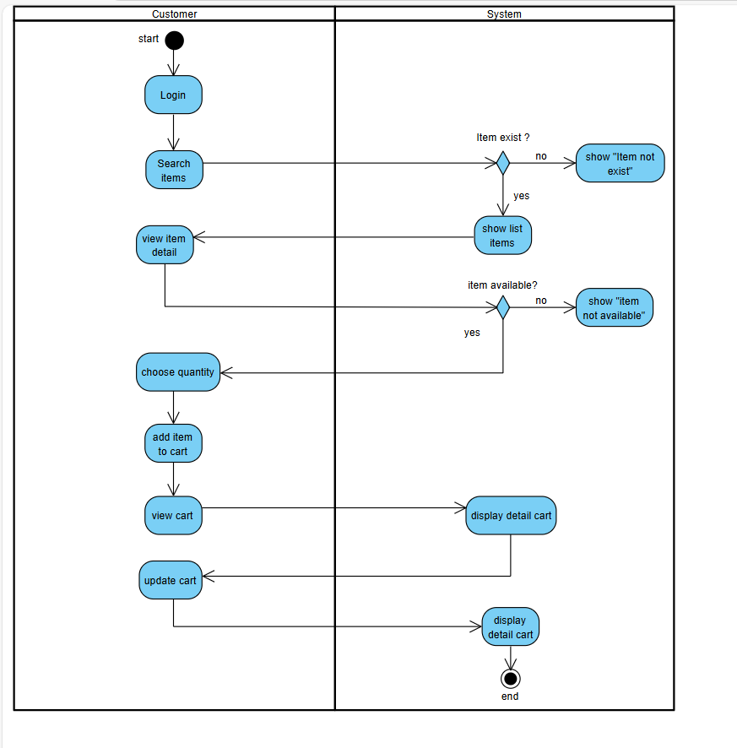

* + - Checkout

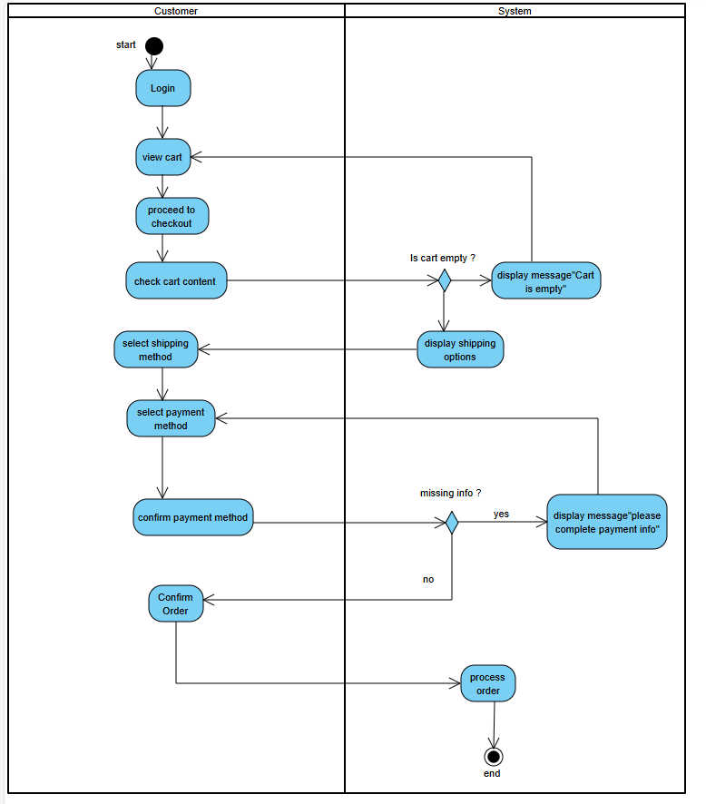

* + - Select ship (drone)

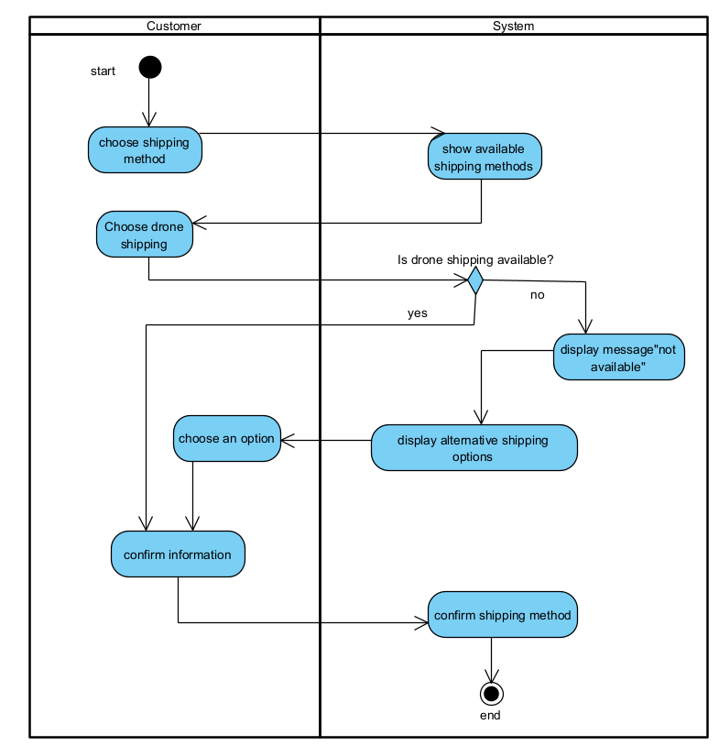

* + - Select pay and ordergive

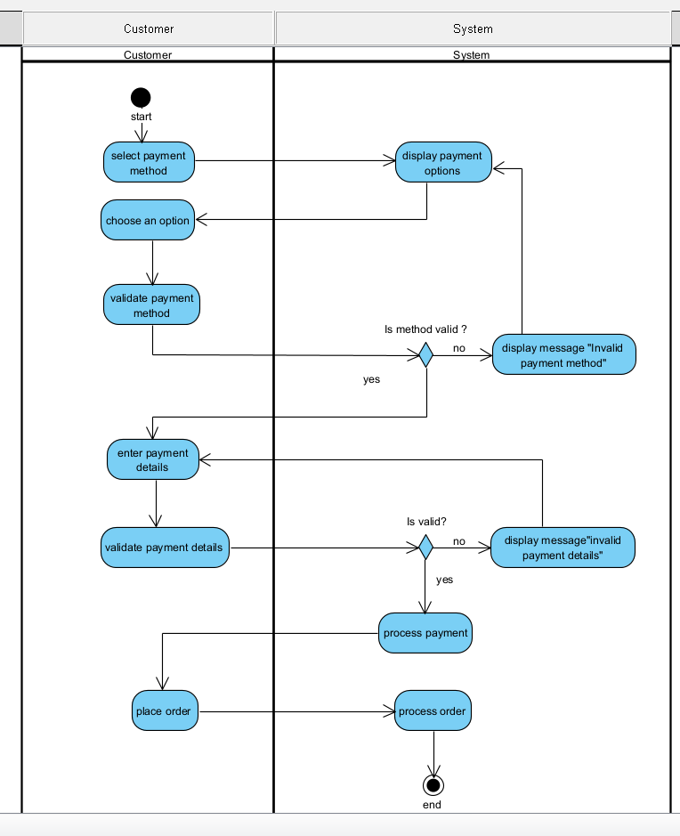

* + - Comments & feed back of items

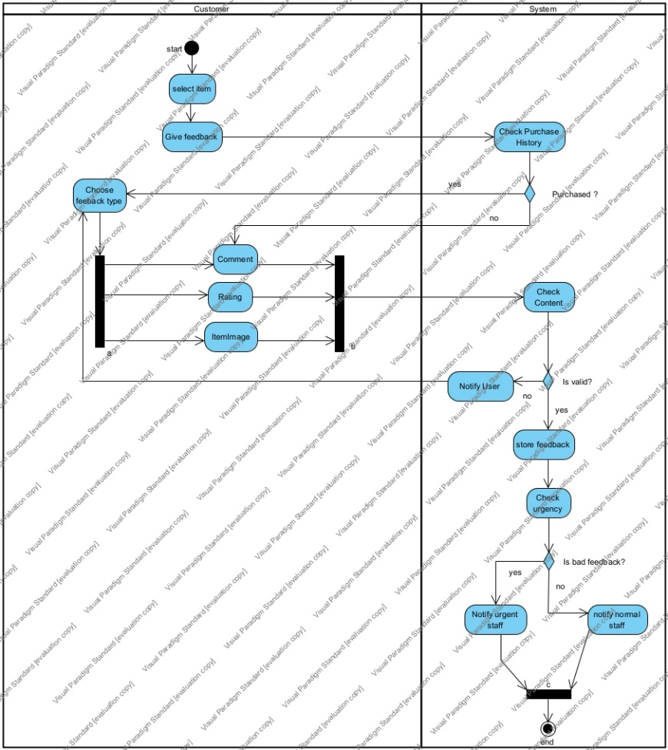

* + - Process order: alert order (automatically), check order, send invoice/feedback to customer, send requirements to ship department and repository

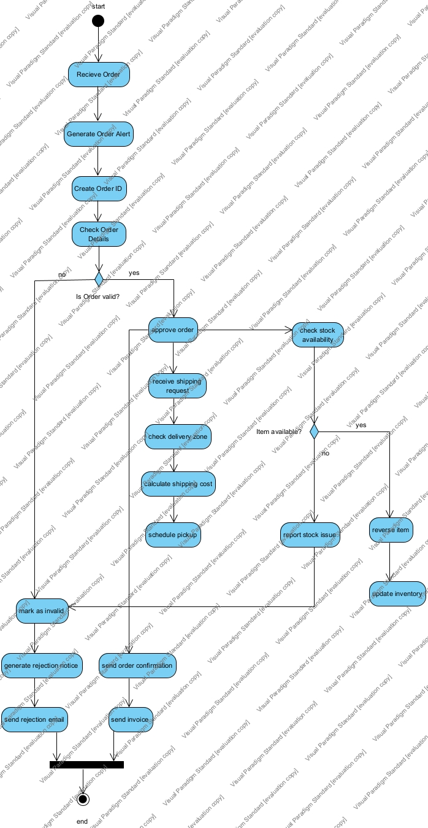

* + - Process payment

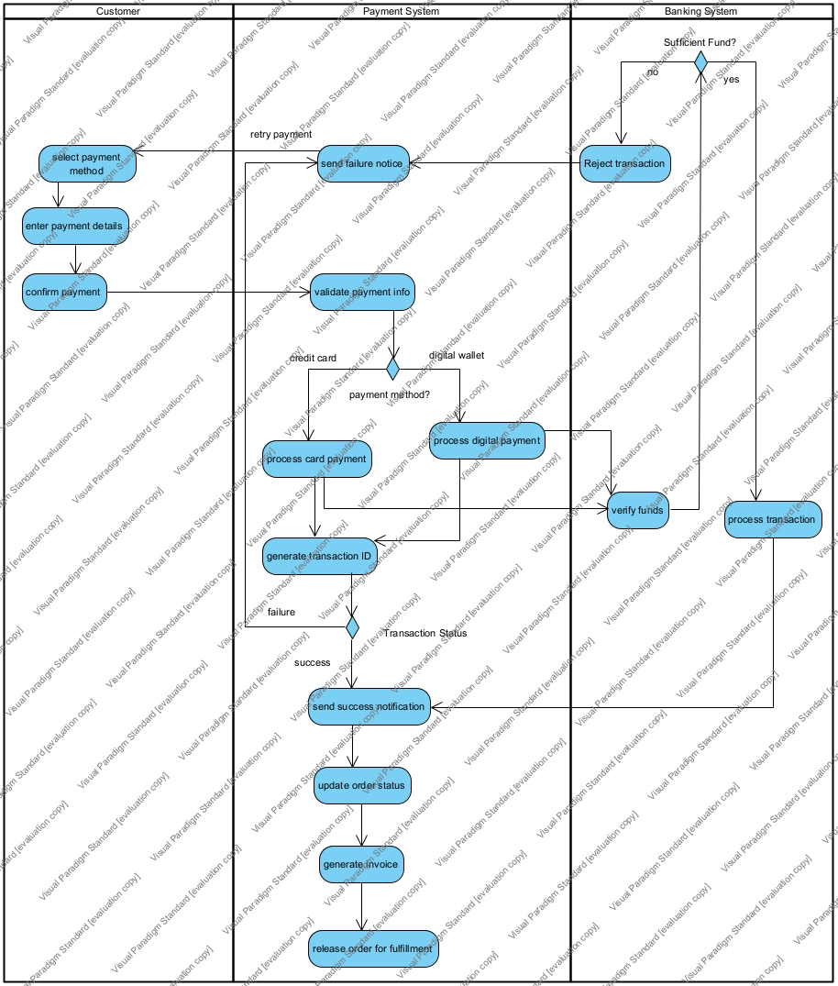

* + - Process shipment (using drone)

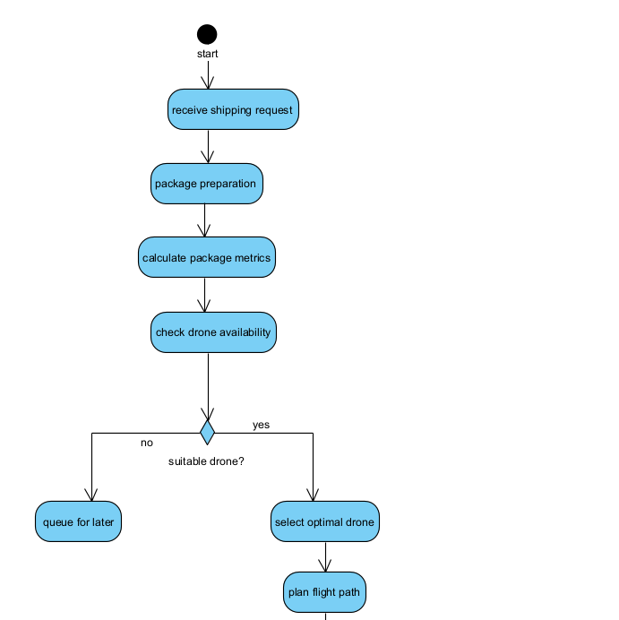

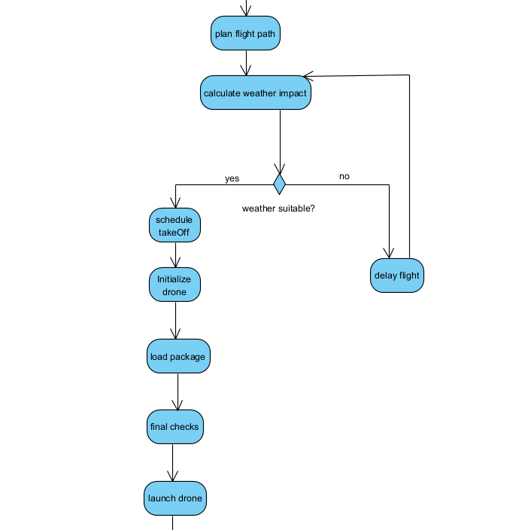

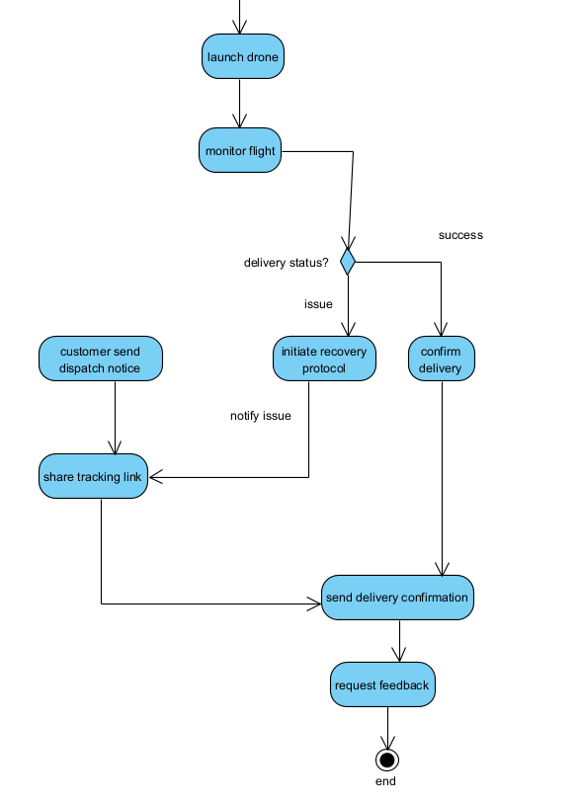

* + 5 sequence diagrams
    - Create cart

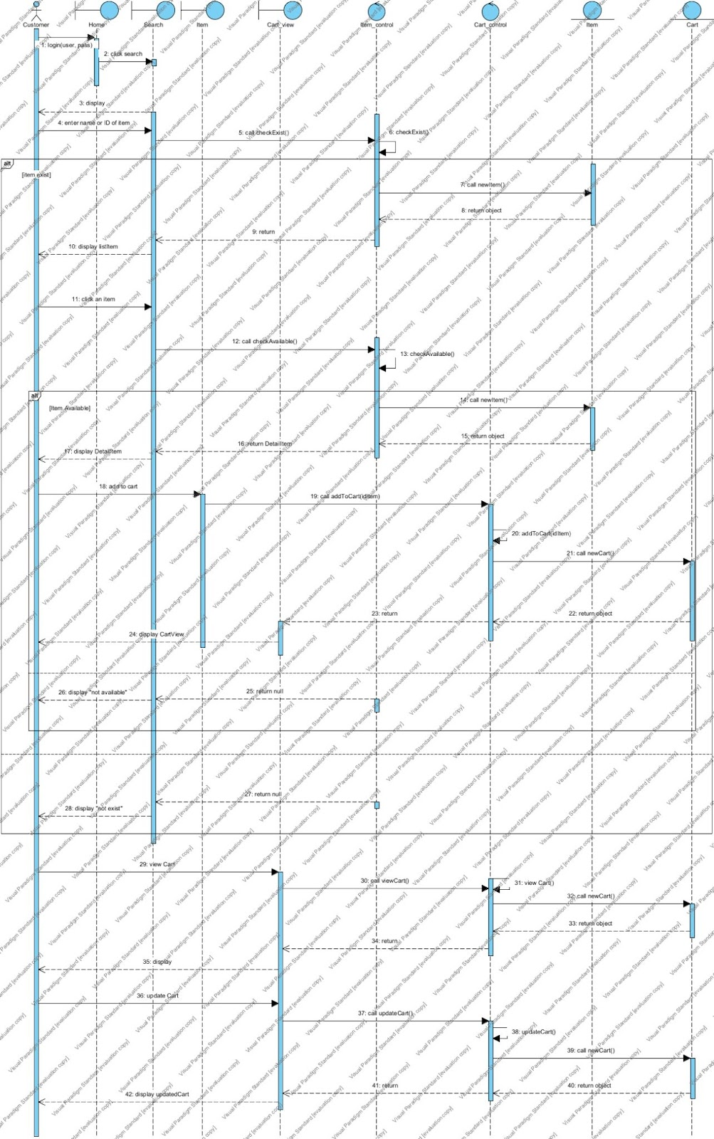

* + - Checkout

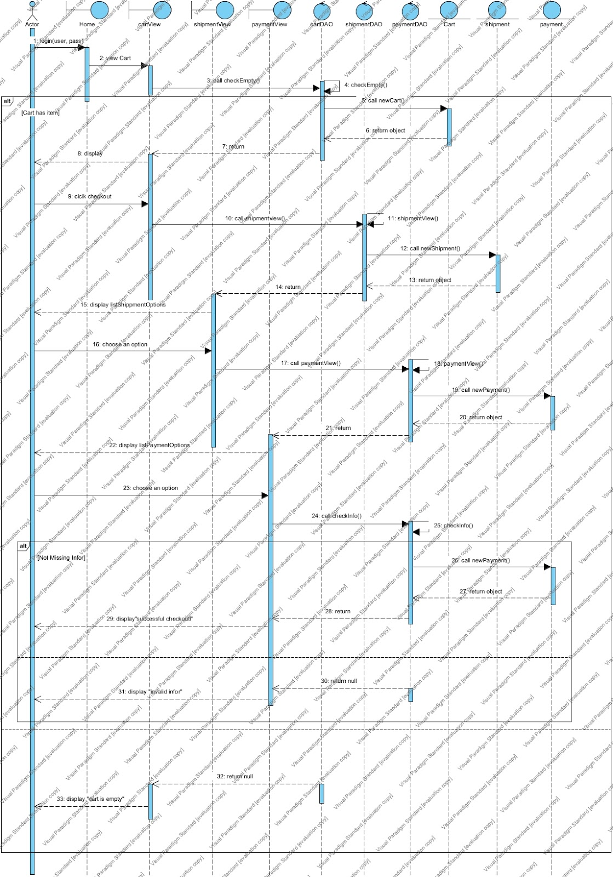

* + - Give feedback

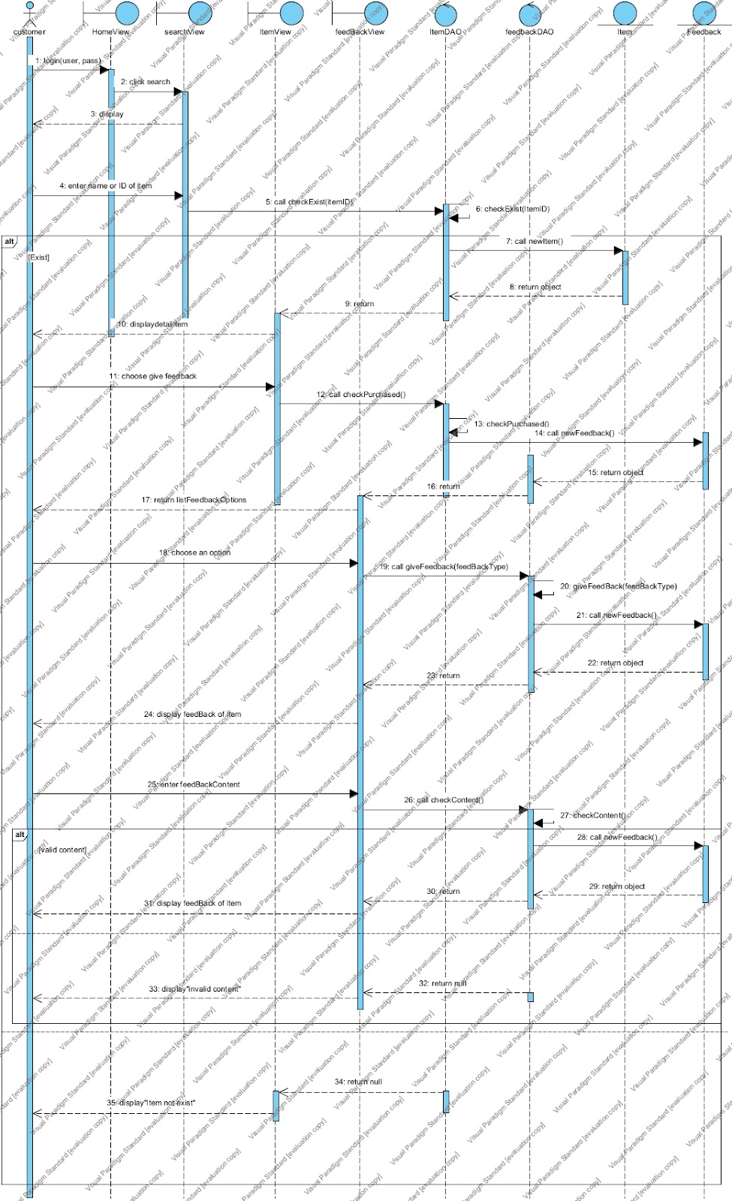

* + - Select pay and order

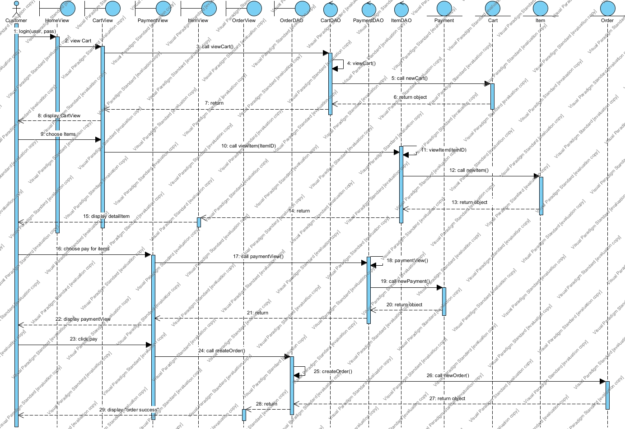

* + - Select shipping

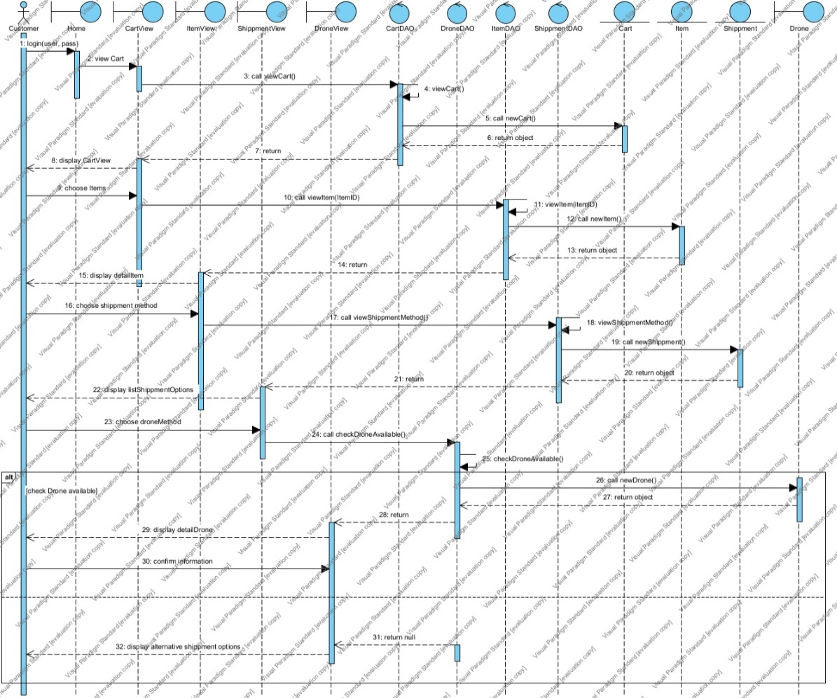

1. Requirement Analysis

* Write 50 CRC Cards
  + User

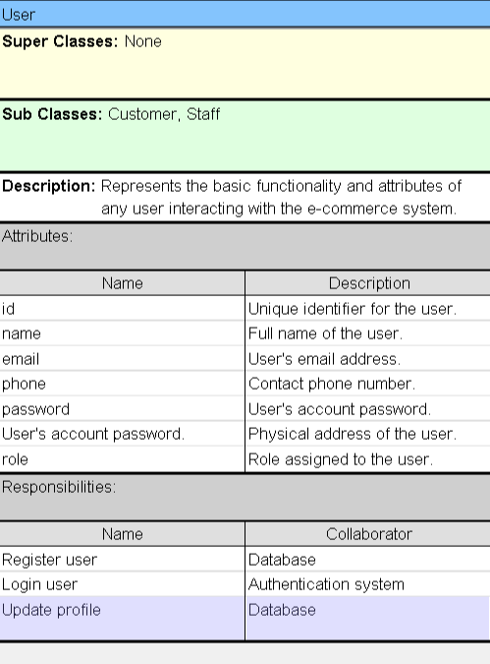

* + Customer

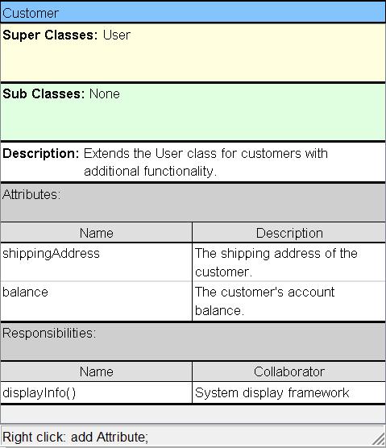

* + Staff

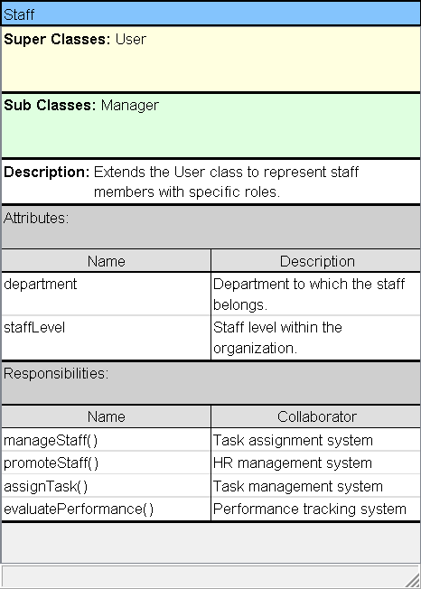

* + Manager

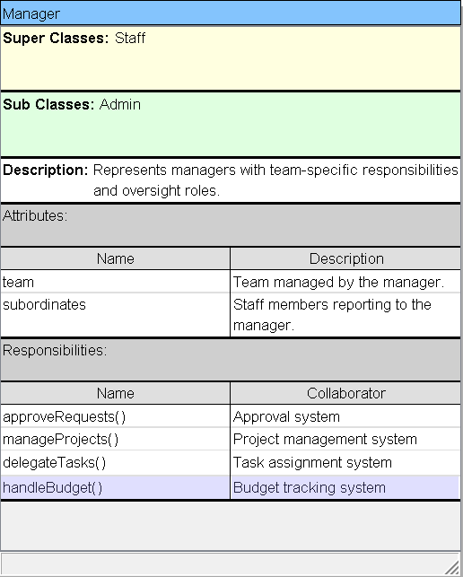

* + Admin

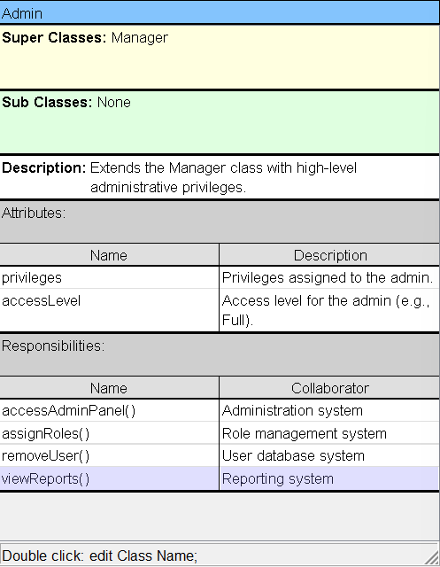

* + Product

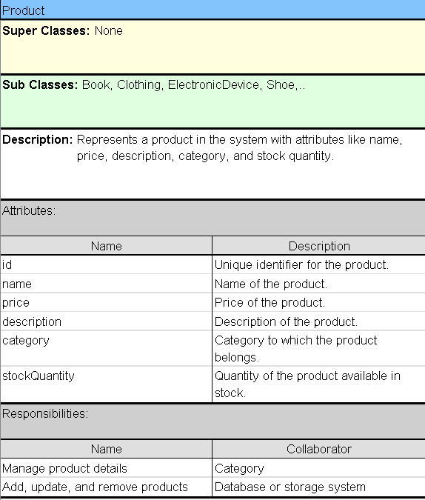

* + Category

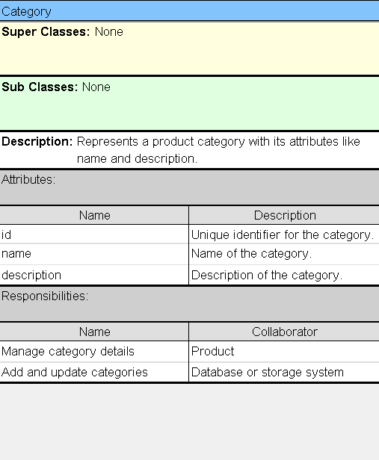

* + Book

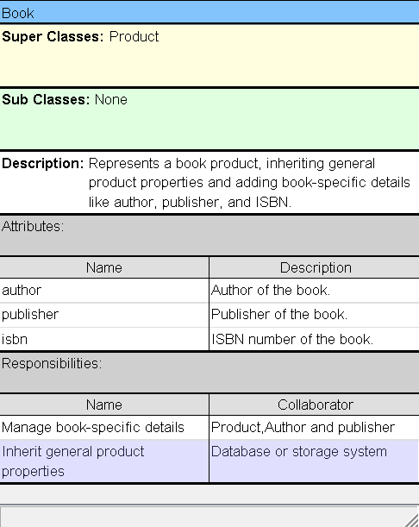

* + Clothes

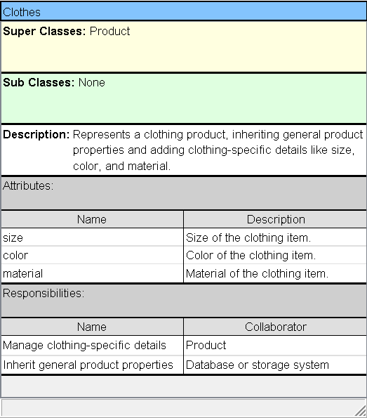

* + Electronic Device

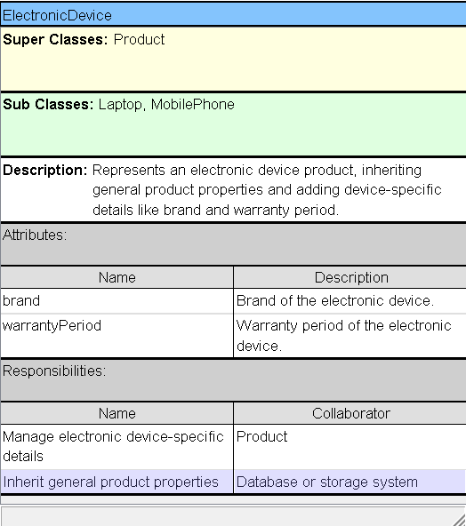

* + Laptop

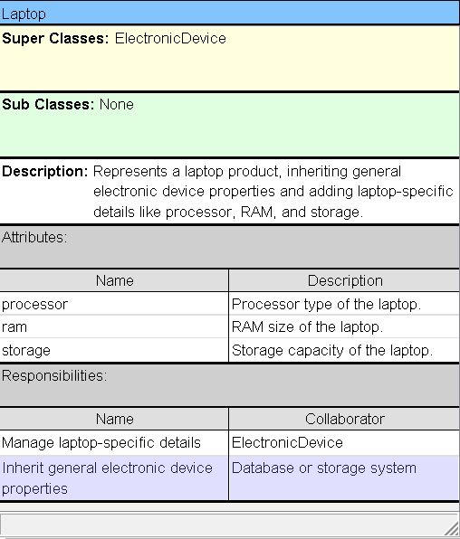

* + MobilePhone

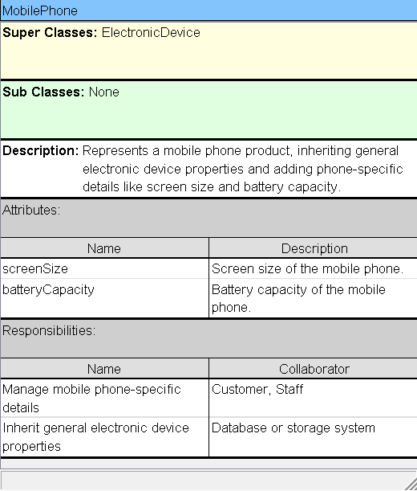

* + Shoes

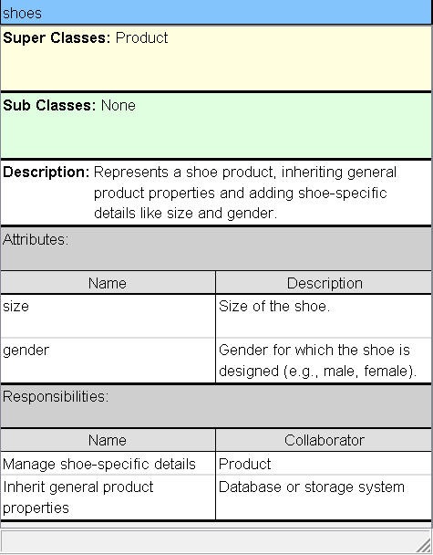

* + Cart

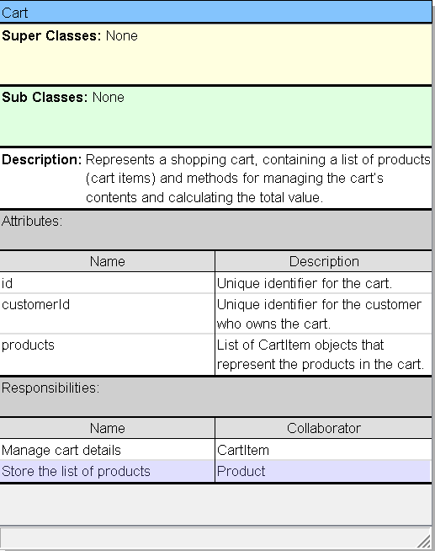

* + CartItem

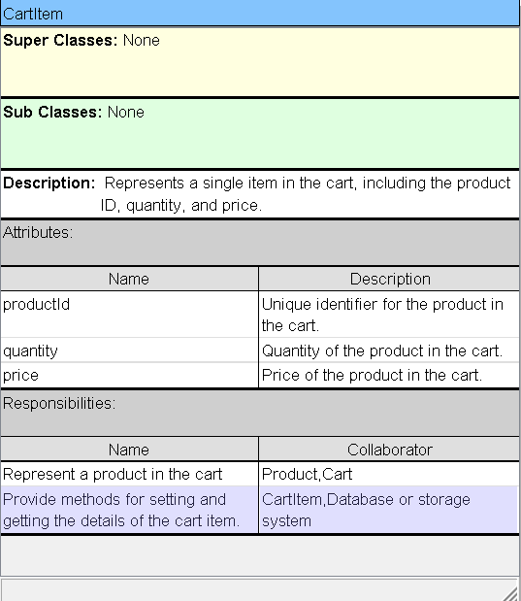

* + Order

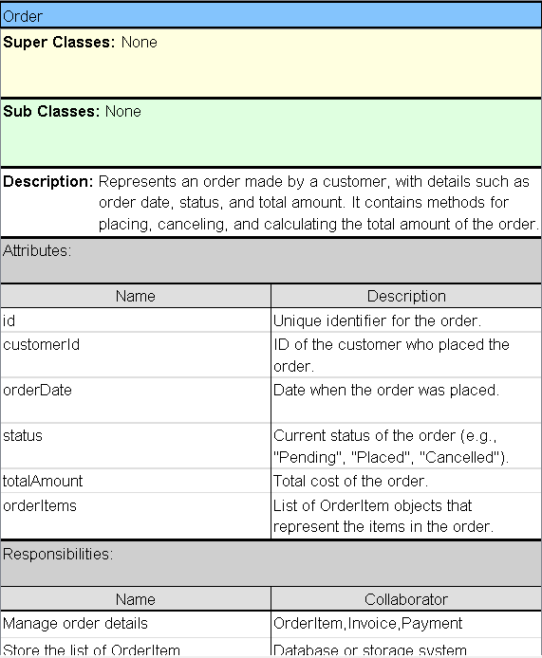

* + OrderItem

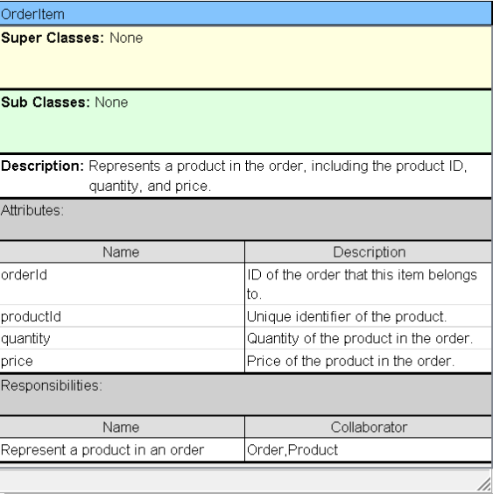

* + Invoice

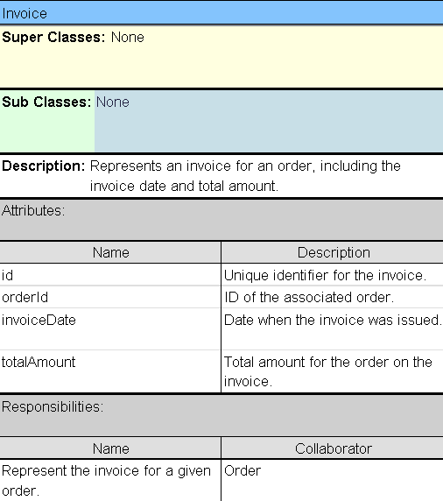

* + OrderStatus

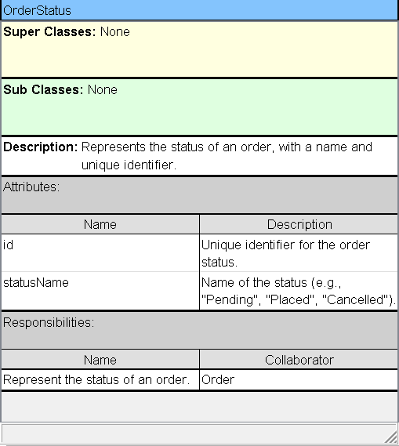

* + Payment

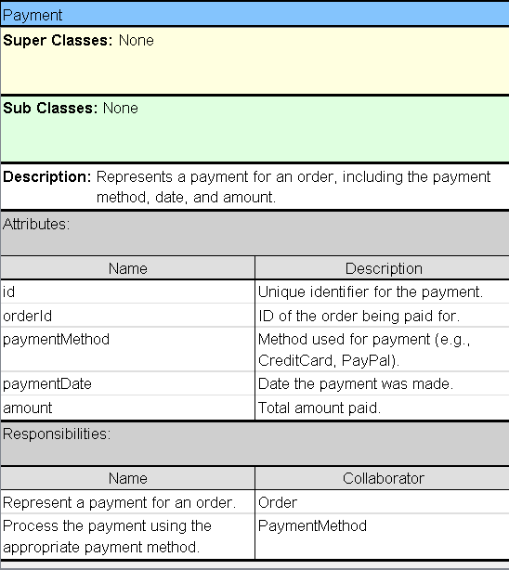

* + PaymentMethod

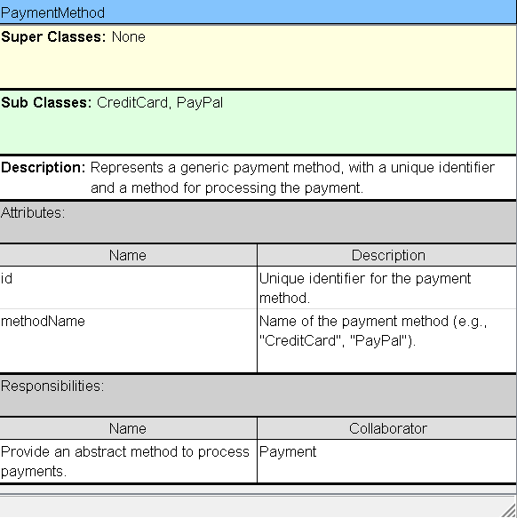

* + CreditCard

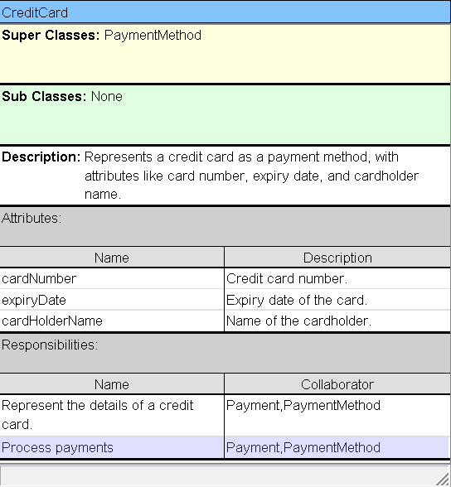

* + PayPal

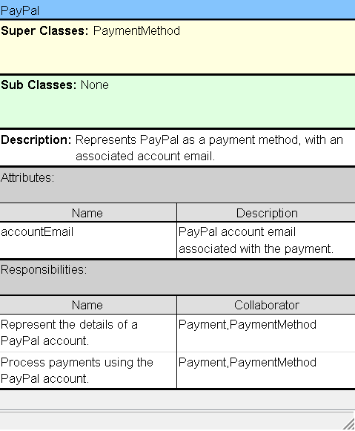

* + Shipment

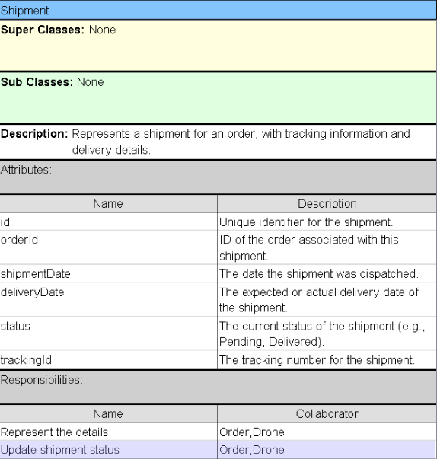

* + Drone

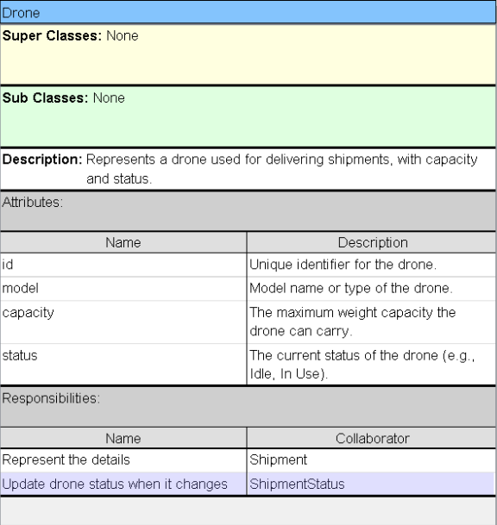

* + ShipmentStatus

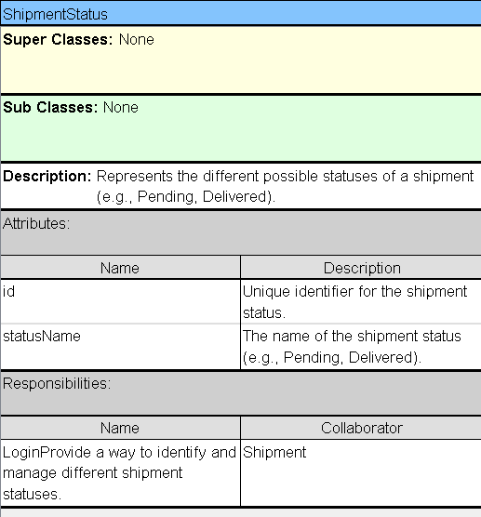

* + Feedback

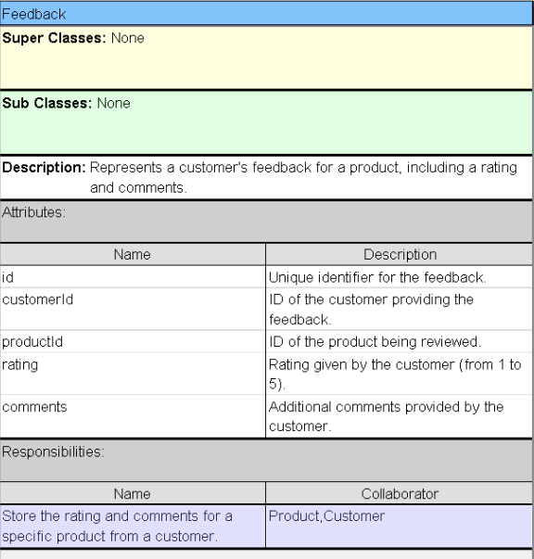

* + Review

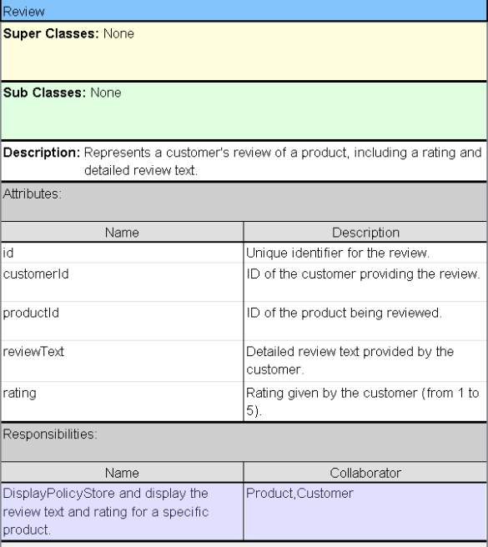

* + Inventory

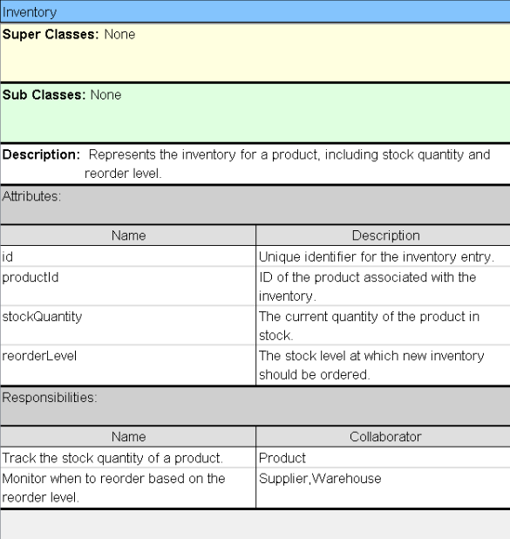

* + Warehouse

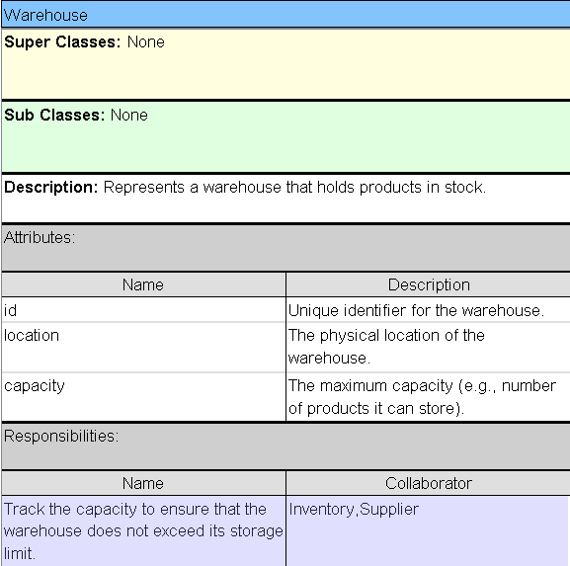

* + Supplier

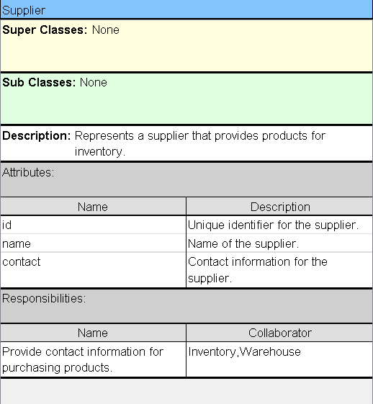

* + Report

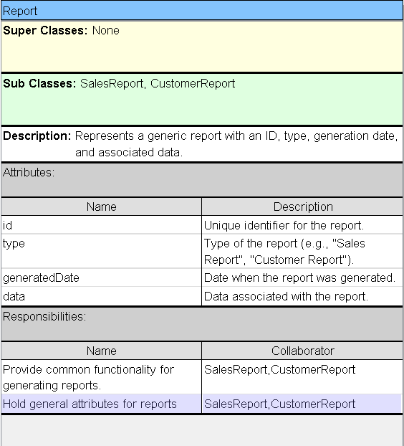

* + SalesReport

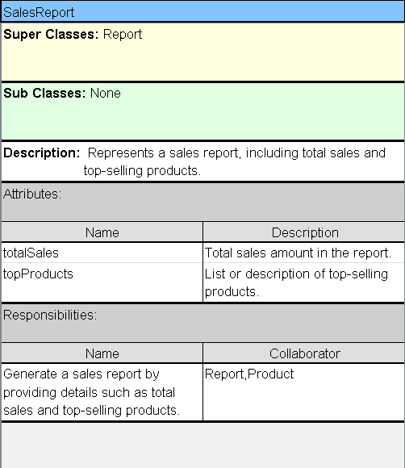

* + CustomerReport

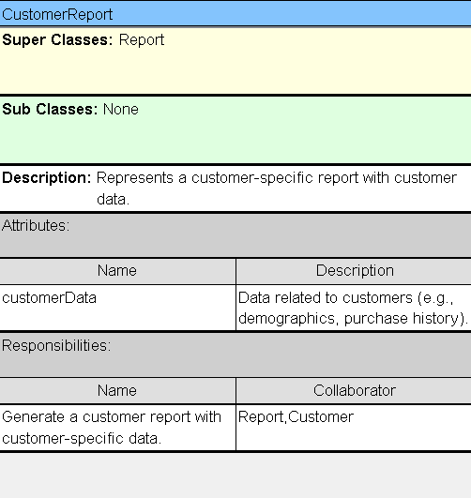

* + Analystic

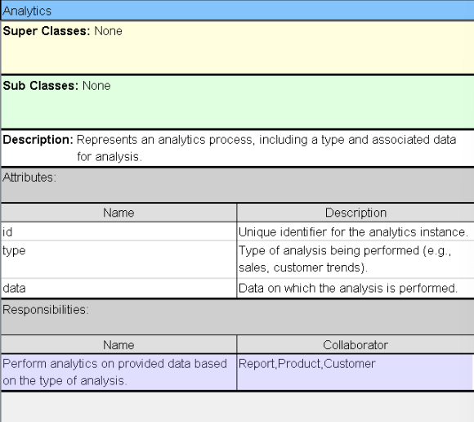

* + Notification

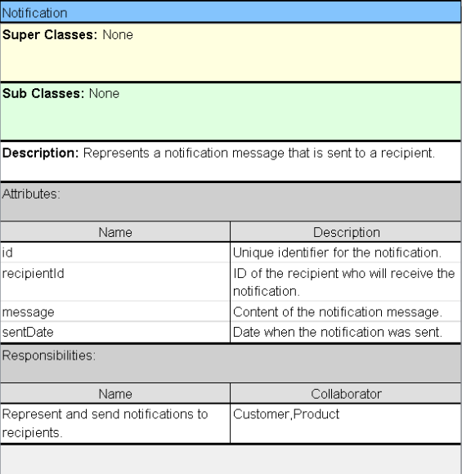

* + Alert

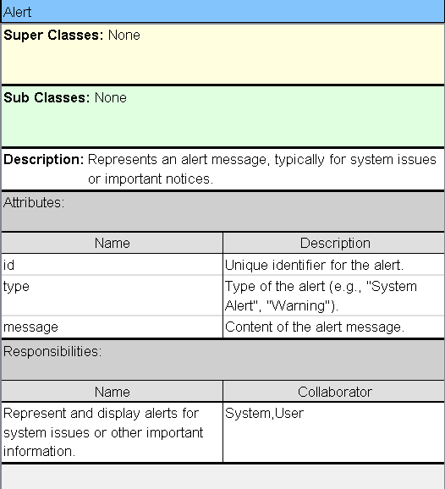

* + SearchModule

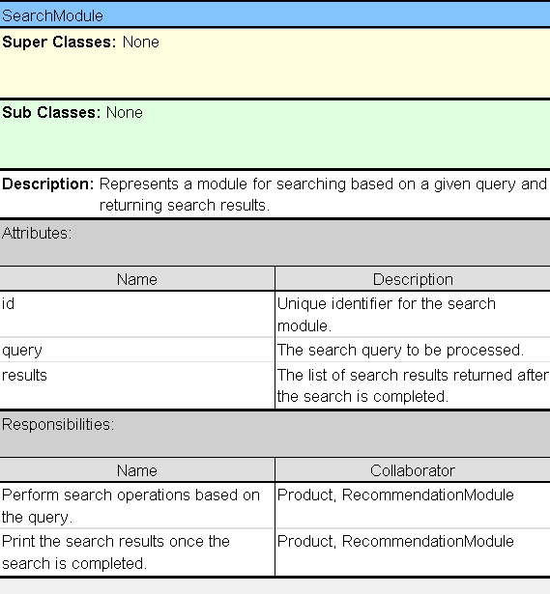

* + RecommendationModule

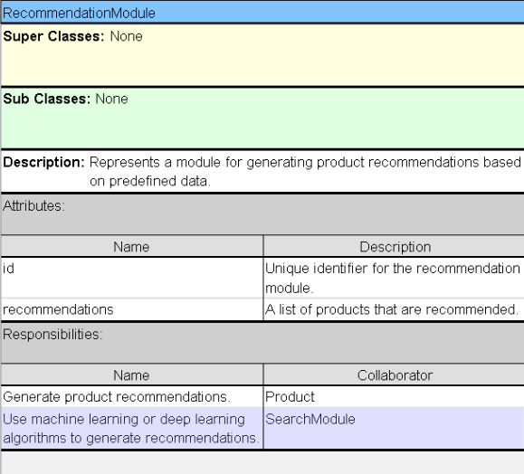

* + OpinionAnalysisModule

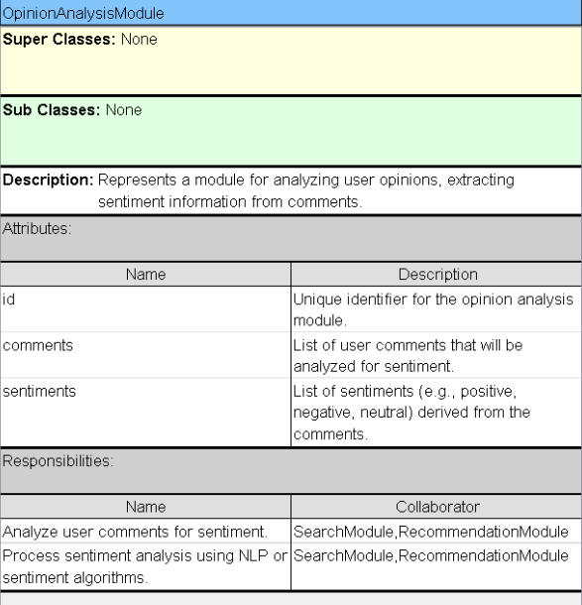

* + SystemConfig

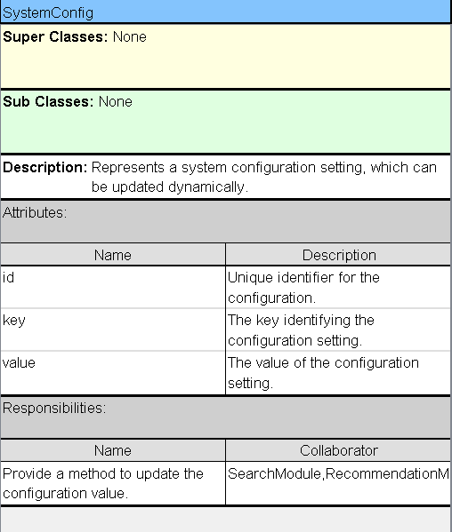

* + ErrorLog

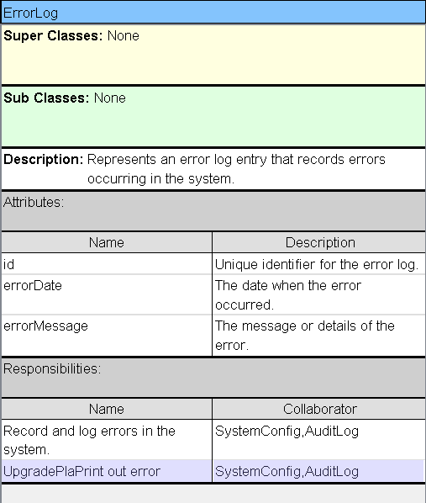

* + AuditLog

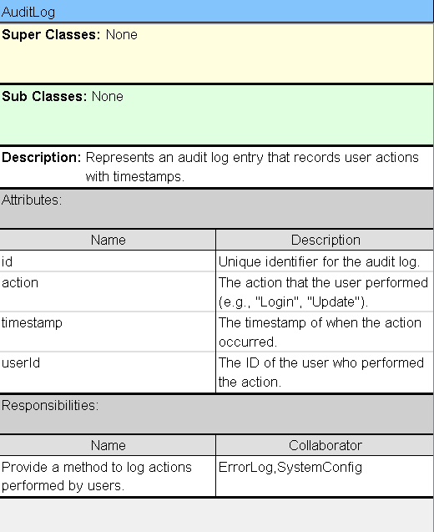

* + Address

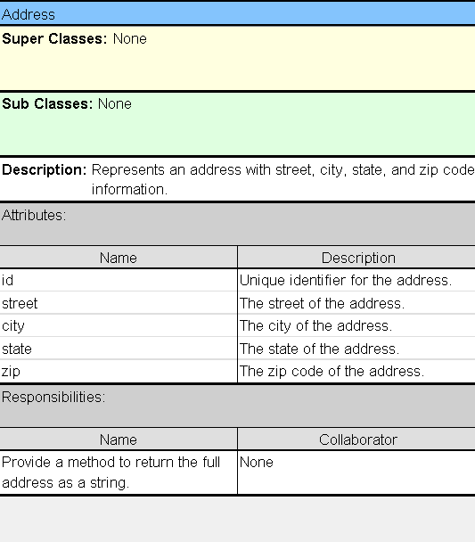

* + FileUpload

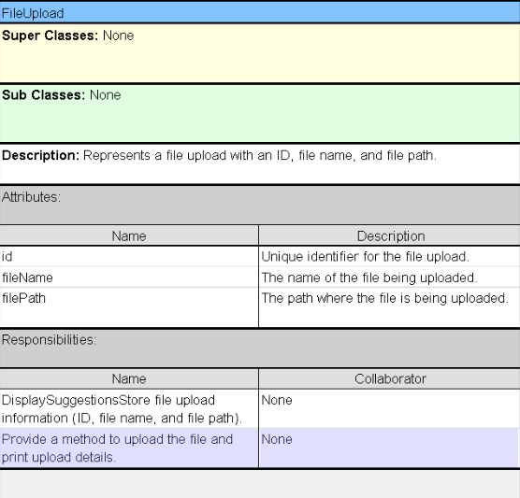

* + Session

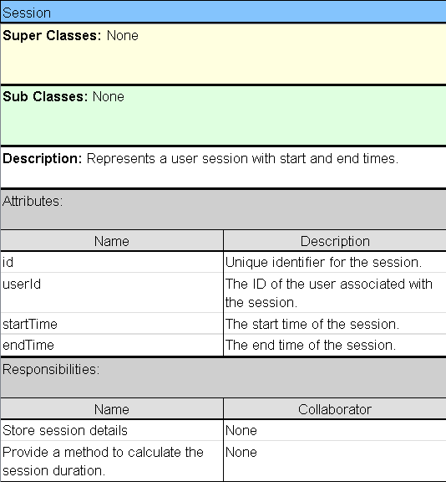

* + Discount

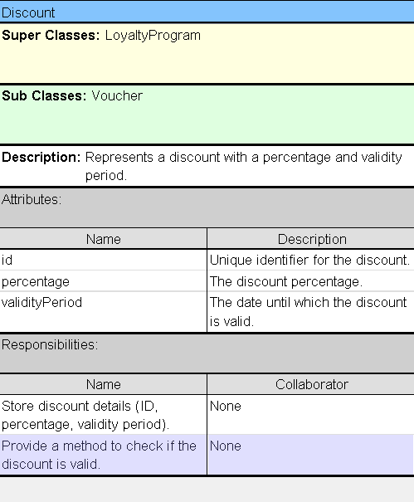

* + Voucher

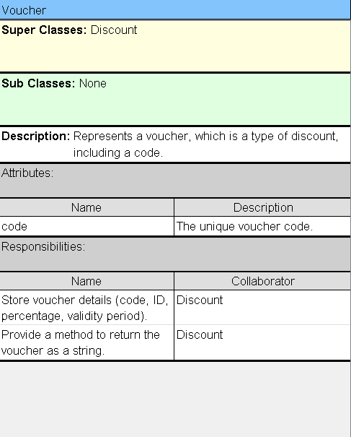

* + Role

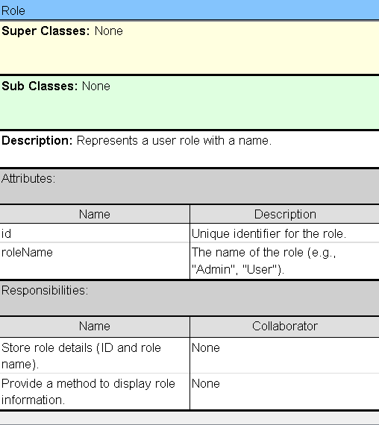

* + Permission

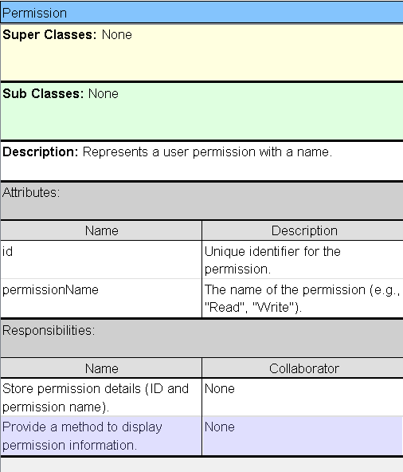

* Draw a class diagram (analysis) with 50 classes

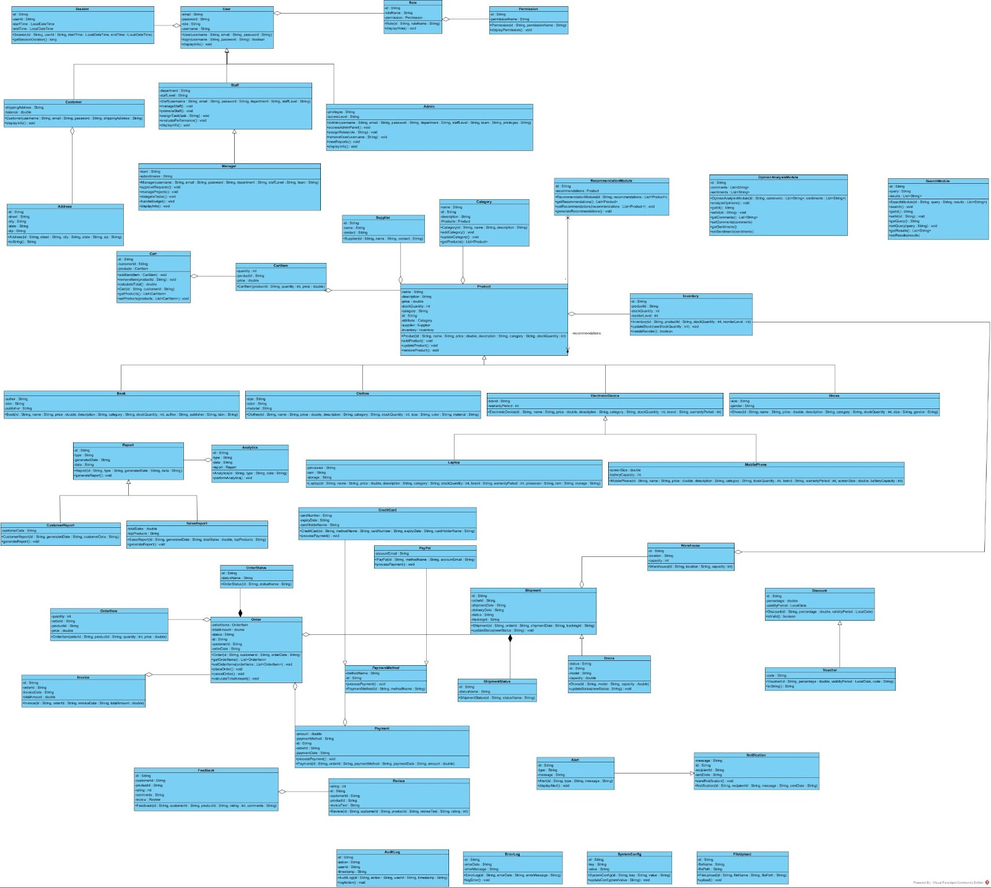

* Construct data dictionary
  + Customer

|  |  |  |  |  |  |  |  |
| --- | --- | --- | --- | --- | --- | --- | --- |
| Field Name | Description | Data Type | Size | Format | Valid Values | Default | Notes |
| customer_id | Unique identifier for each customer | Integer | 10 | - | - | Auto-increment | Primary key |
| name | Full name of the customer | Varchar | 100 | - | - | - | - |
| email | Customer's email address | Varchar | 255 | Email | - | - | Must be unique and valid |
| phone_number | Customer's phone number | Varchar | 10 | - | - | - | - |
| address | Customer's shipping address | Varchar | 255 | - | - | - | - |

* + Product

|  |  |  |  |  |  |  |  |
| --- | --- | --- | --- | --- | --- | --- | --- |
| Field Name | Description | Data Type | Size | Format | Valid Values | Default | Notes |
| product_id | Unique identifier for each product | Integer | 10 | - | - | Auto-increment | Primary key |
| name | Name of the product | Varchar | 255 | - | - | - | - |
| description | Detailed description of the product | Text | - | - | - | - | - |
| category | Product category | Varchar | 50 | - | "book", "clothing", "mobile", etc. | "book" | - |
| price | Price of the product | Decimal | 10.2   |  | | --- | |  |  |  | | --- | |  | | - | - | 0.0 | - |
| stock_quantity | Number of items in stock | Integer | 10 | - | >=0 | 0 | - |

* + Staff

|  |  |  |  |  |  |  |  |
| --- | --- | --- | --- | --- | --- | --- | --- |
| Field Name | Description | Data Type | Size | Format | Valid Values | Default | Notes |
| staff_id | Unique identifier for each staff member | Integer | 10 | - | - | Auto-increment | Primary key |
| name | Full name of the staff | Varchar | 100 | - | - | - | - |
| email | Staff member's email address | Varchar | 255 | Email | - | - | Must be unique and valid |
| role | Role of the staff (manager, sales, admin) | Varchar | 50 | - | "manager", "sales", "admin" | "sales" | Defines staff access level |
| phone_number | Staff member's phone number | Varchar | 15 | - | - | - | - |
| address | Staff member's address | Varchar | 255 | - | - | - | - |

* + Order

|  |  |  |  |  |  |  |  |
| --- | --- | --- | --- | --- | --- | --- | --- |
| Field Name | Description | Data Type | Size | Format | Valid Values | Default | Notes |
| order_id | Unique identifier for each order member | Integer | 10 | - | - | Auto-increment | Primary key |
| customer_id | ID of the customer placing the order | Integer | 10 | - | - | - | Foreign key linking to Customer |
| status | Status of the order | Varchar | 20 | - | "pending", "shipped", "delivered", "canceled" | "pending" | Current order status |
| total_amount | Total cost of the order | Decimal | 10,2 | - | >=0 | 0.0 | - |
| shipping_address | Shipping address for the order | Varchar | 255 | - | - | - | - |

* + Payment

|  |  |  |  |  |  |  |  |
| --- | --- | --- | --- | --- | --- | --- | --- |
| Field Name | Description | Data Type | Size | Format | Valid Values | Default | Notes |
| payment_id | Unique identifier for each payment | Integer | 10 | - | - | Auto-increment | Primary key |
| order_id | Associated order ID | Integer | 10 | - | - | - | Foreign key linking to Order |
| payment_date | Date of payment | Date | - | YYYY-MM-DD | - | - | - |
| amount | Amount paid | Decimal | 10,2 | - | >=0 | 0.0 | - |
| payment_method | Method of payment | Varchar | 50 | - | "credit card", "PayPal", "bank transfer", etc. | "credit card" | - |
| status | Status of the payment | Varchar | 20 | - | "completed", "pending", "failed" | "pending" | Current payment status |

* Create data model

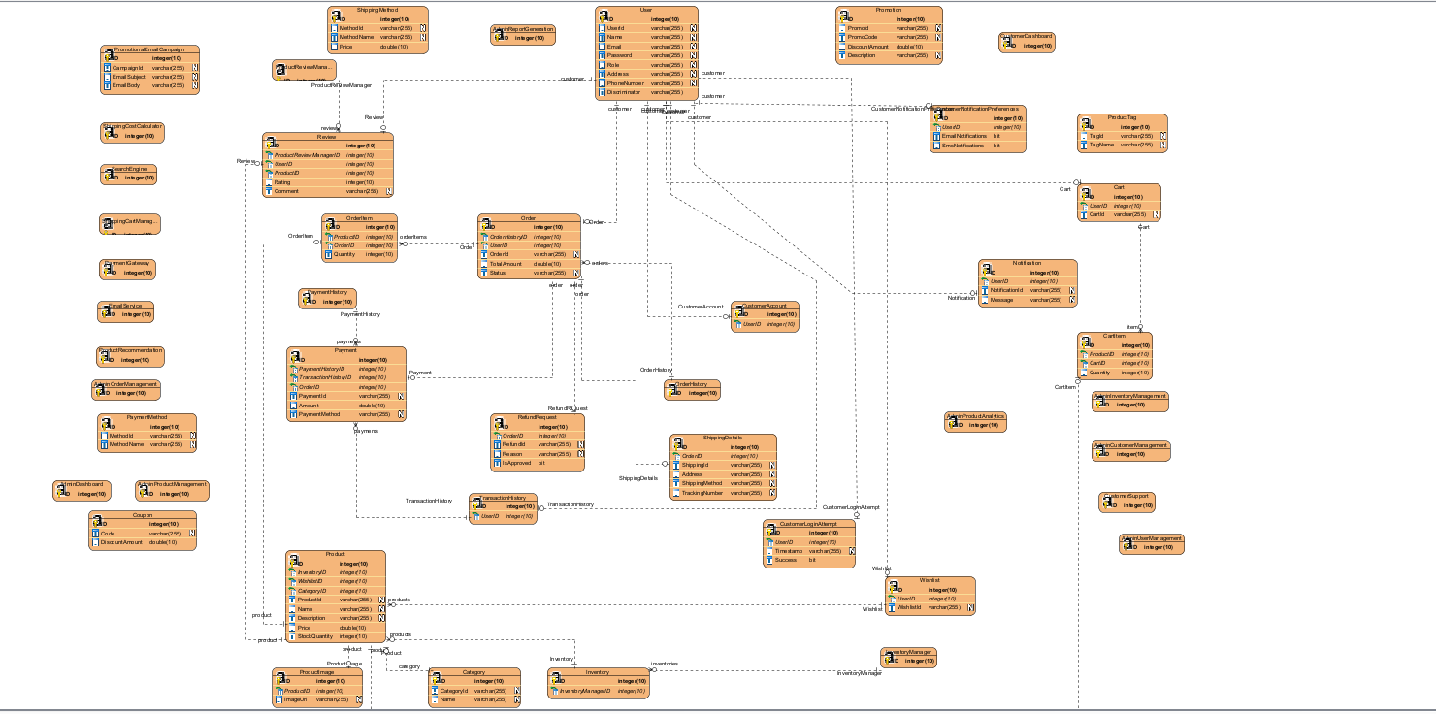

1. Design

* Overall design

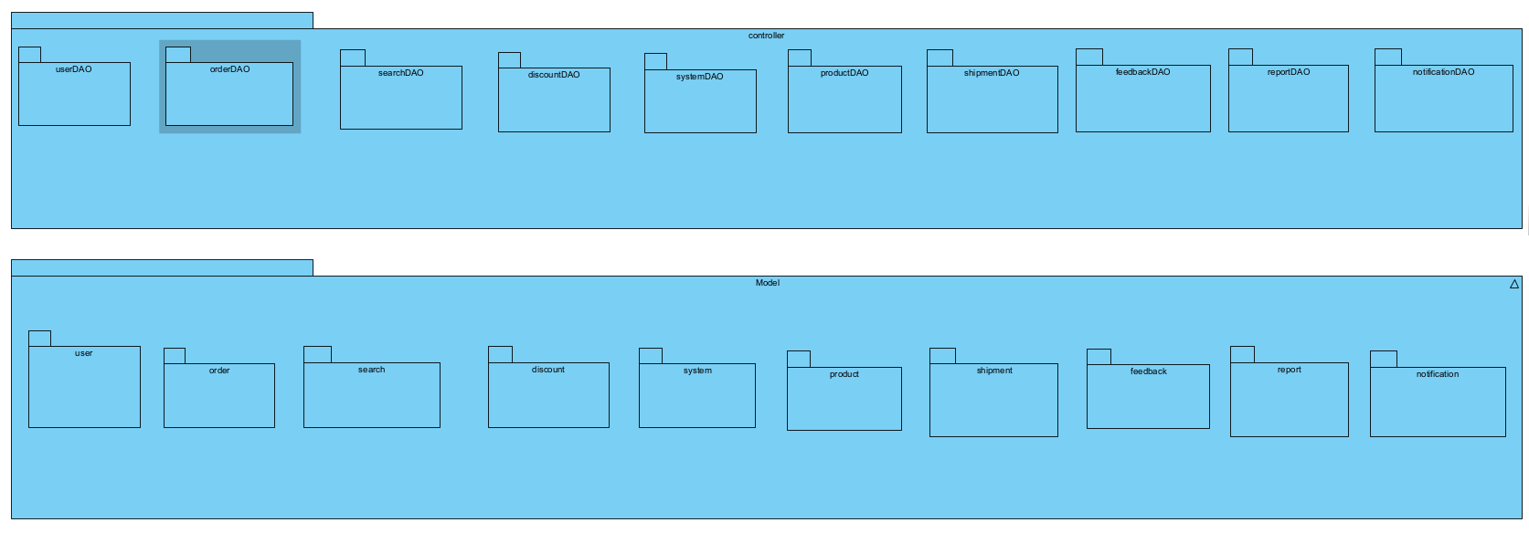

* Detailed design
  + User

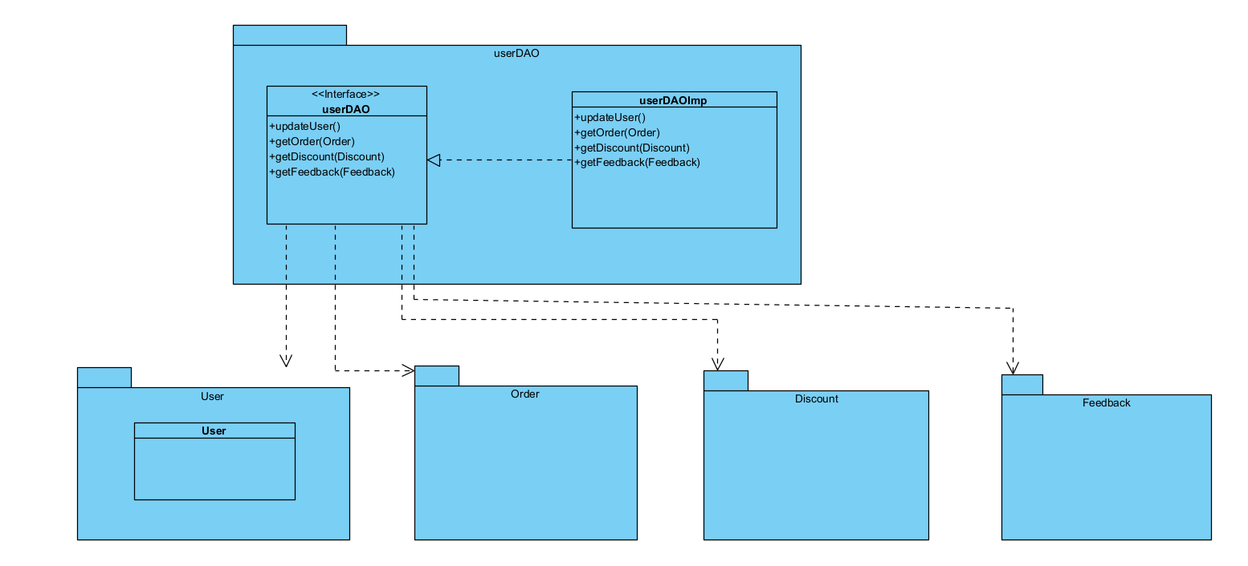

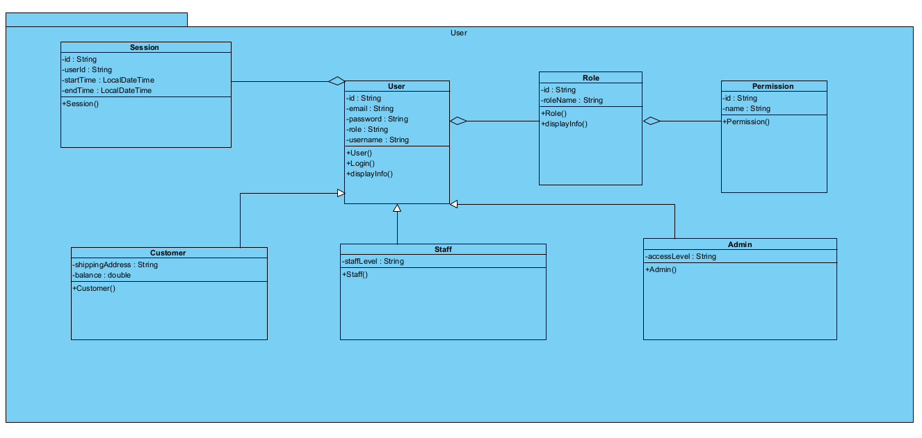

* + Order

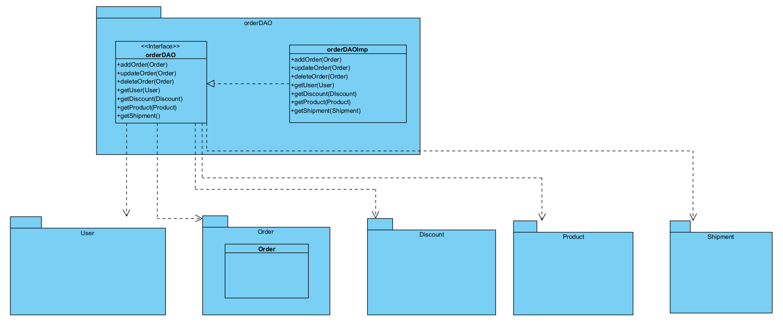

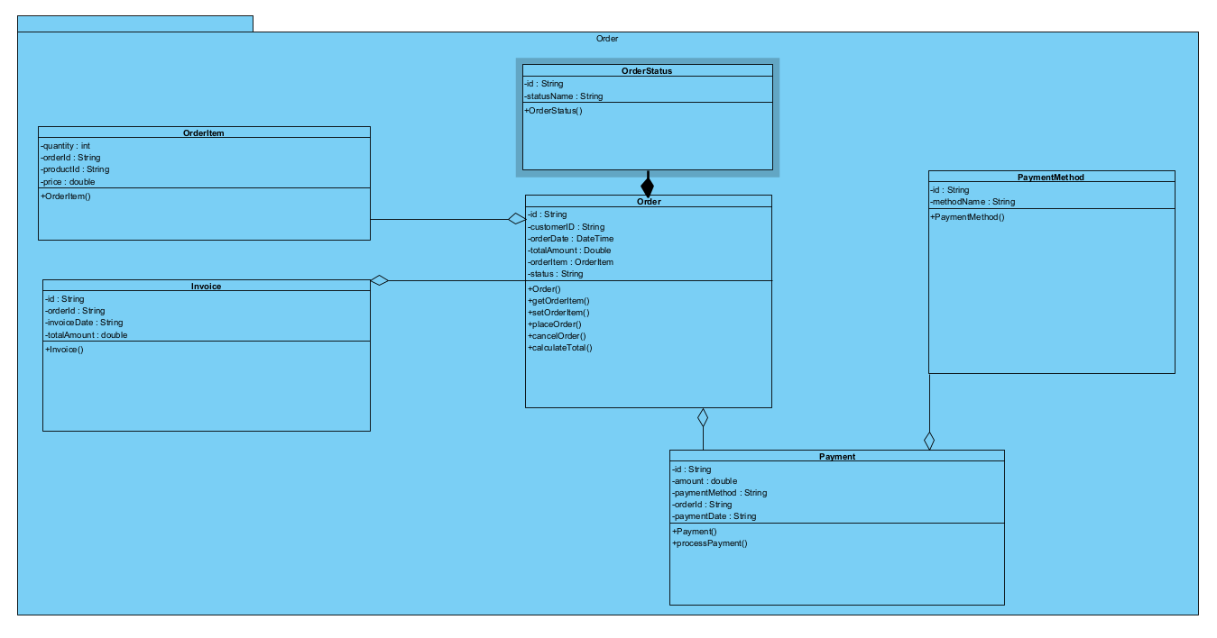

* + Search

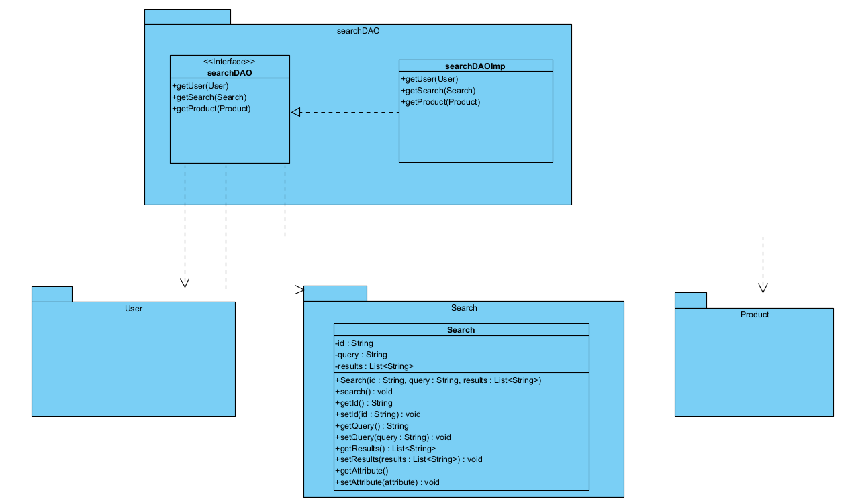

* + Discount

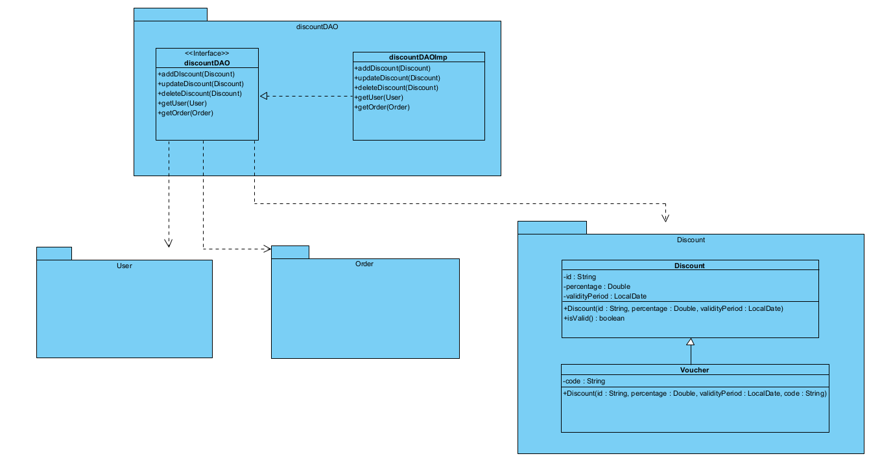

* + System

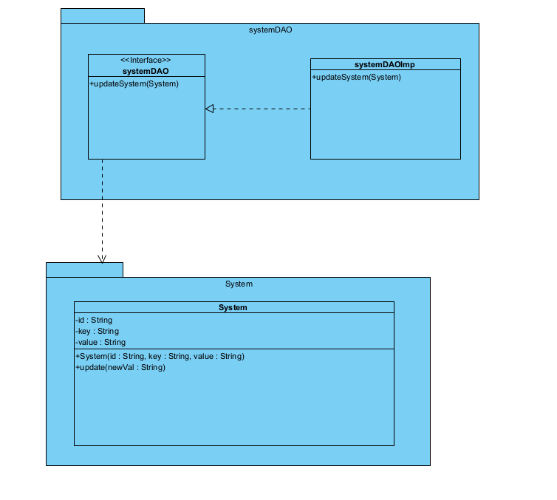

* + Product

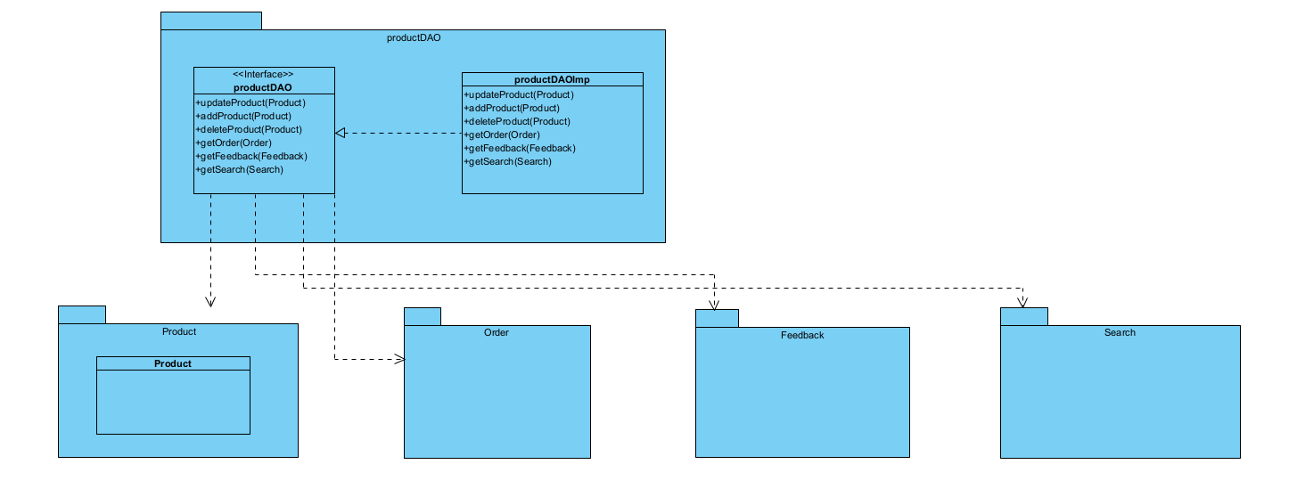

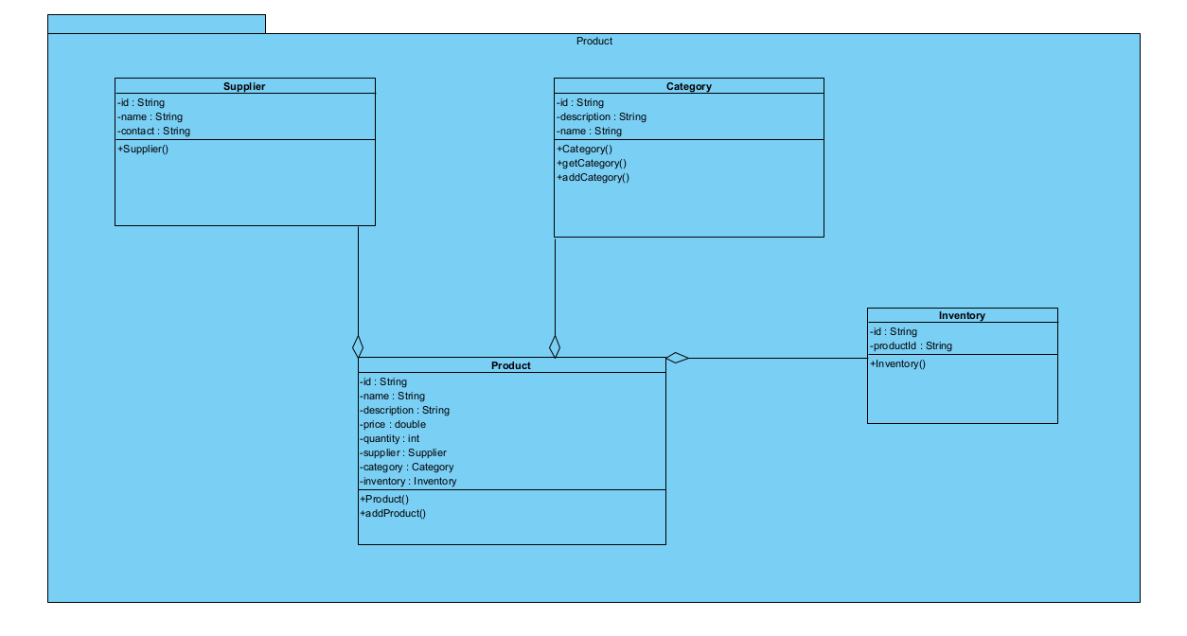

* + Shipment

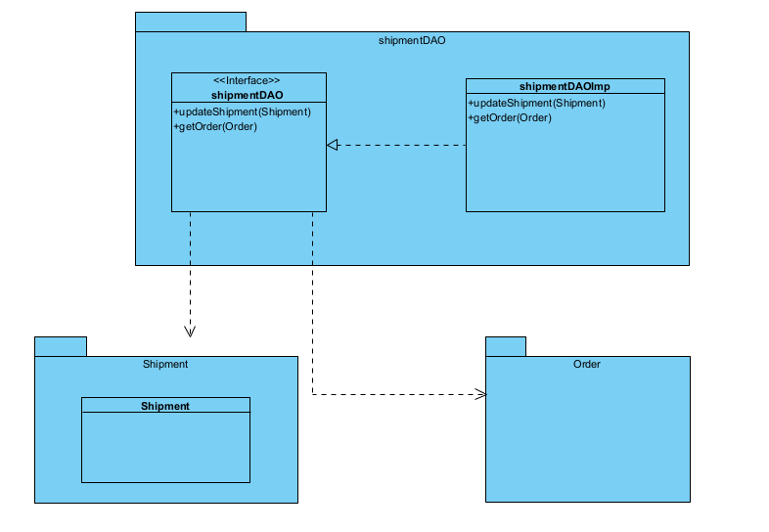

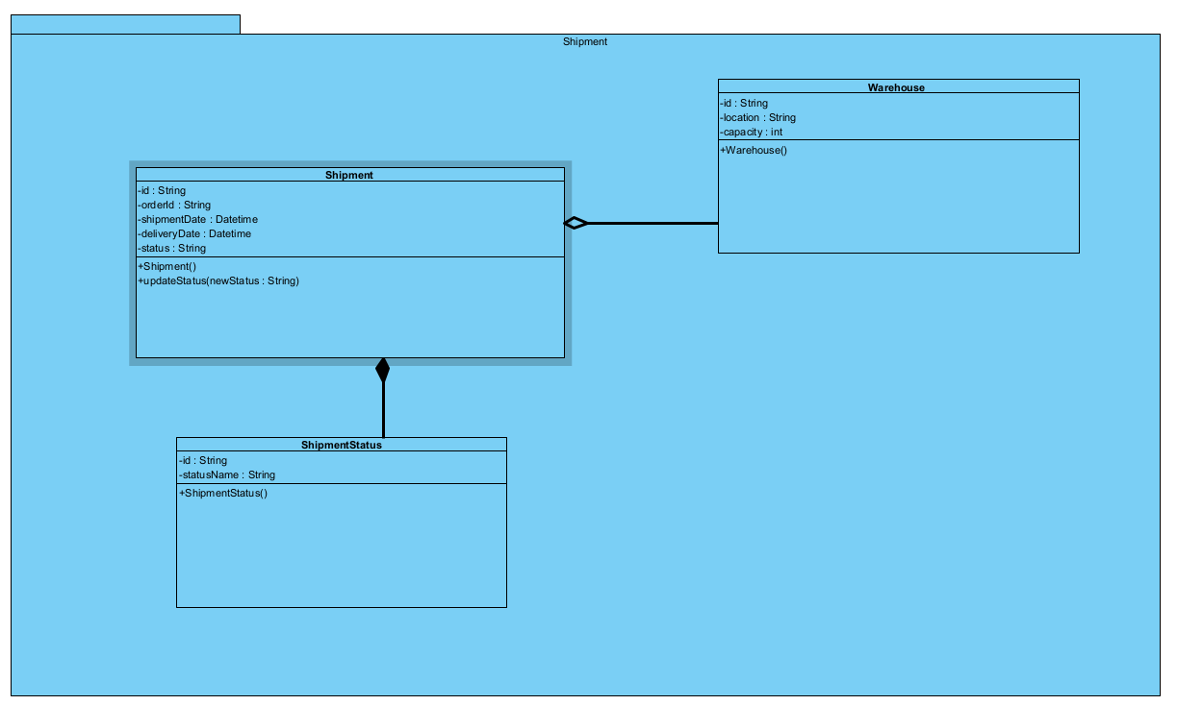

* + FeedBack

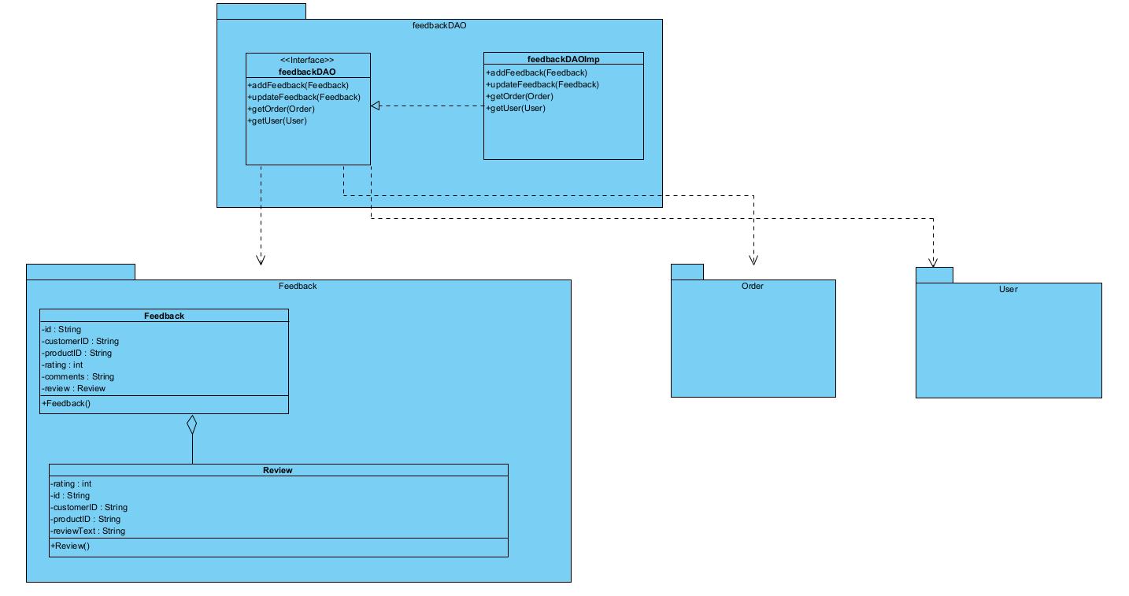

* + Report

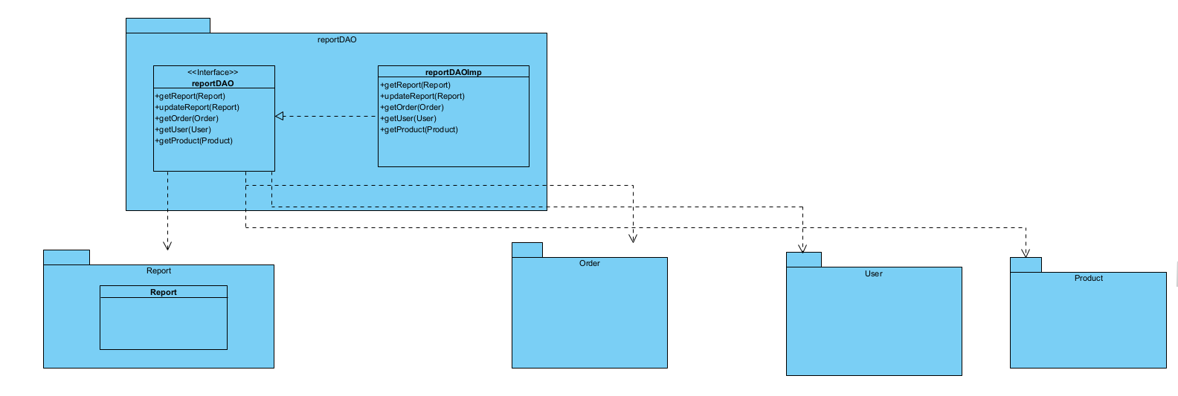

* + Notification

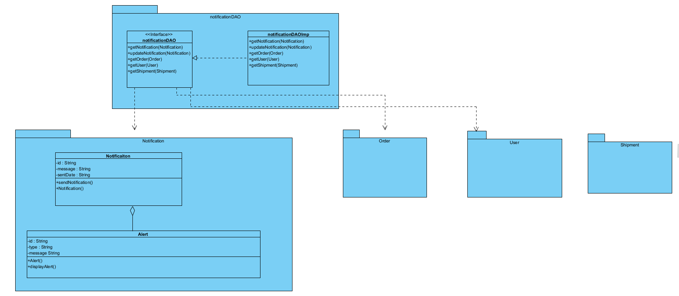

* Design forms such as bill, report....
  + Bill

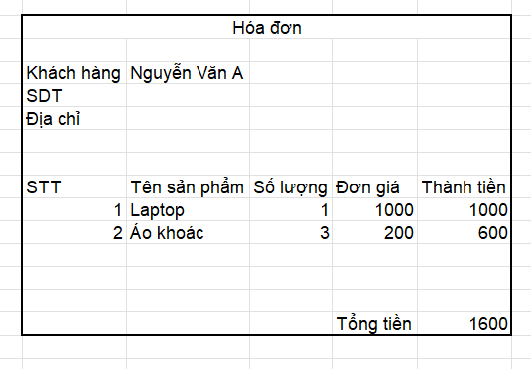

* + FeedBack

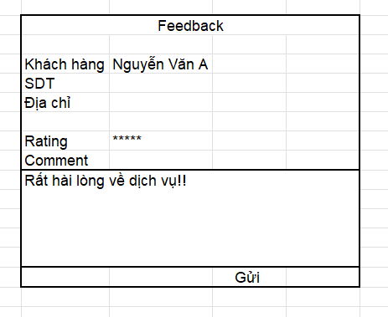

1. Programming and Integration

* Project structure

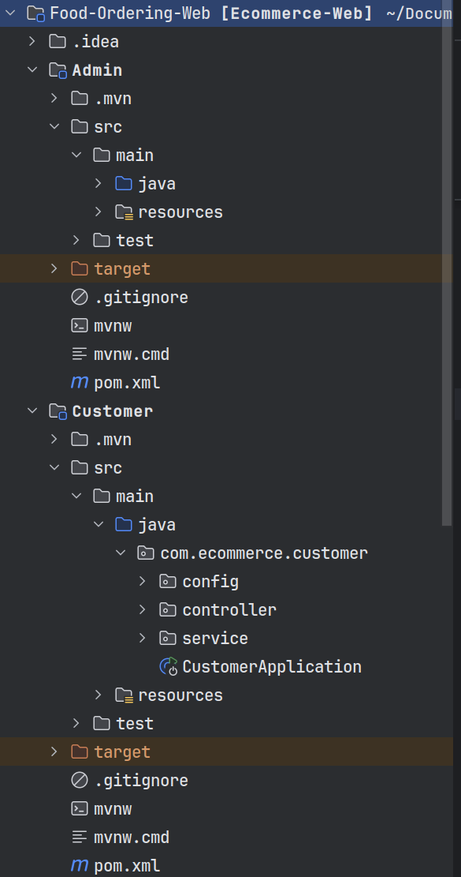  
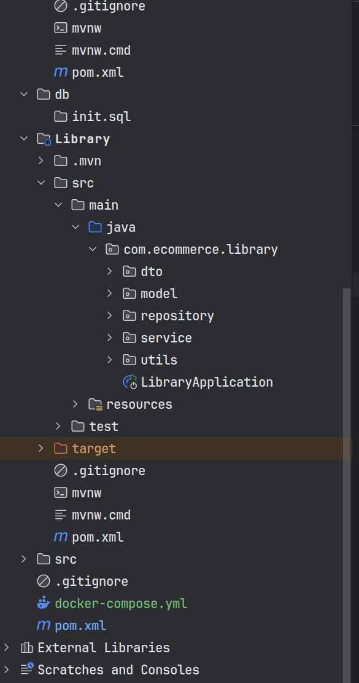

* Code

package com.ecommerce.admin.config;

import org.springframework.boot.autoconfigure.security.servlet.PathRequest;

import org.springframework.context.annotation.Bean;

import org.springframework.context.annotation.Configuration;

import org.springframework.security.authentication.AuthenticationManager;

import org.springframework.security.config.annotation.authentication.builders.AuthenticationManagerBuilder;

import org.springframework.security.config.annotation.web.builders.HttpSecurity;

import org.springframework.security.config.annotation.web.configuration.EnableWebSecurity;

import org.springframework.security.config.annotation.web.configurers.AbstractHttpConfigurer;

import org.springframework.security.config.http.SessionCreationPolicy;

import org.springframework.security.core.userdetails.UserDetailsService;

import org.springframework.security.crypto.bcrypt.BCryptPasswordEncoder;

import org.springframework.security.web.SecurityFilterChain;

import org.springframework.security.web.util.matcher.AntPathRequestMatcher;

@Configuration

@EnableWebSecurity

public class AdminConfiguration {

   @Bean

   public UserDetailsService userDetailsService(){

       return new AdminServiceConfig();

   }

   @Bean

   public BCryptPasswordEncoder passwordEncoder(){

       return new BCryptPasswordEncoder();

   }

   @Bean

   public SecurityFilterChain filterChain(HttpSecurity http) throws Exception {

       AuthenticationManagerBuilder authenticationManagerBuilder

               = http.getSharedObject(AuthenticationManagerBuilder.class);

       authenticationManagerBuilder

               .userDetailsService(userDetailsService())

               .passwordEncoder(passwordEncoder());

       AuthenticationManager authenticationManager = authenticationManagerBuilder.build();

       http

               .csrf(AbstractHttpConfigurer::disable)

               .authorizeHttpRequests( author ->

                       author.requestMatchers(PathRequest.*toStaticResources*().atCommonLocations()).permitAll()

                               .requestMatchers("/admin/**").hasAuthority("ADMIN")

                               .requestMatchers("/forgot-password", "/register", "/register-new").permitAll()

                               .anyRequest().authenticated()

               )

               .formLogin(login ->

                       login.loginPage("/login")

                               .loginProcessingUrl("/do-login")

                               .defaultSuccessUrl("/index", true)

                               .permitAll()

               )

               .logout(logout ->

                       logout.invalidateHttpSession(true)

                               .clearAuthentication(true)

                               .logoutRequestMatcher(new AntPathRequestMatcher("/logout"))

                               .logoutSuccessUrl("/login?logout")

                               .permitAll()

               )

               .authenticationManager(authenticationManager)

               .sessionManagement(session ->

                       session.sessionCreationPolicy(SessionCreationPolicy.*ALWAYS*)

               )

       ;

       return http.build();

   }

}

package com.ecommerce.admin.config;

import com.ecommerce.library.model.Admin;

import com.ecommerce.library.model.Role;

import org.springframework.security.core.GrantedAuthority;

import org.springframework.security.core.authority.SimpleGrantedAuthority;

import org.springframework.security.core.userdetails.UserDetails;

import java.util.ArrayList;

import java.util.Collection;

import java.util.List;

public class AdminDetails implements UserDetails {

   private Admin admin;

   @Override

   public Collection<? extends GrantedAuthority> getAuthorities() {

       List<SimpleGrantedAuthority> authorities = new ArrayList<>();

       for (Role role : admin.getRoles()){

           authorities.add(new SimpleGrantedAuthority(role.getName()));

       }

       return authorities;

   }

   @Override

   public String getPassword() {

       return admin.getPassword();

   }

   @Override

   public String getUsername() {

       return admin.getUserName();

   }

   @Override

   public boolean isAccountNonExpired() {

       return true;

   }

   @Override

   public boolean isAccountNonLocked() {

       return true;

   }

   @Override

   public boolean isCredentialsNonExpired() {

       return true;

   }

   @Override

   public boolean isEnabled() {

       return true;

   }

}

package com.ecommerce.admin.config;

import com.ecommerce.library.model.Admin;

import com.ecommerce.library.repository.AdminRepository;

import org.springframework.beans.factory.annotation.Autowired;

import org.springframework.security.core.authority.SimpleGrantedAuthority;

import org.springframework.security.core.userdetails.User;

import org.springframework.security.core.userdetails.UserDetails;

import org.springframework.security.core.userdetails.UserDetailsService;

import org.springframework.security.core.userdetails.UsernameNotFoundException;

import org.springframework.stereotype.Service;

import java.util.stream.Collectors;

@Service

public class AdminServiceConfig implements UserDetailsService {

   @Autowired

   private AdminRepository adminRepository;

   @Override

   public UserDetails loadUserByUsername(String username) throws UsernameNotFoundException {

       Admin admin = adminRepository.findByUserName(username);

       if (admin == null) {

           throw new UsernameNotFoundException("Could not find username");

       }

       return new User(

               admin.getUserName(),

               admin.getPassword(),

               admin.getRoles()

                       .stream()

                       .map(role -> new SimpleGrantedAuthority(role.getName())).collect(Collectors.*toList*()));

   }

}

package com.ecommerce.admin.controller;

import org.springframework.stereotype.Controller;

import org.springframework.ui.Model;

import org.springframework.web.bind.annotation.GetMapping;

@Controller

public class AdminController {

//    @GetMapping("/categories")

//    public String categories(Model model){

//        model.addAttribute("title", "Category");

//        return "categories";

//    }

}

package com.ecommerce.admin.controller;

import com.ecommerce.library.model.Category;

import com.ecommerce.library.service.CategoryService;

import org.springframework.beans.factory.annotation.Autowired;

import org.springframework.dao.DataIntegrityViolationException;

import org.springframework.stereotype.Controller;

import org.springframework.ui.Model;

import org.springframework.web.bind.annotation.*;

import org.springframework.web.servlet.mvc.support.RedirectAttributes;

import java.security.Principal;

import java.util.List;

@Controller

public class CategoryController {

   @Autowired

   private CategoryService categoryService;

   @GetMapping("/categories")

   public String categories(Model model, Principal principal){

       if(principal == null){

           return "redirect:/login";

       }

       List<Category> categories = categoryService.findAll();

       model.addAttribute("categories", categories);

       model.addAttribute("size", categories.size());

       model.addAttribute("title", "Category");

       model.addAttribute("categoryNew", new Category());

       return "categories";

   }

   @PostMapping("/add-category")

   public String add(@ModelAttribute("categoryNew") Category category, RedirectAttributes attributes){

       try{

           categoryService.save(category);

           attributes.addFlashAttribute("success", "Added successfully!");

       }catch(DataIntegrityViolationException e){

           e.printStackTrace();

           attributes.addFlashAttribute("failed", "Failed to add because duplicate name");

       }catch(Exception e){

           e.printStackTrace();

           attributes.addFlashAttribute("failed", "Error server");

       }

       return "redirect:/categories";

   }

   @RequestMapping(value = "/findById/{id}", method = RequestMethod.GET)

   @ResponseBody

   public Category findById(@PathVariable Long id){

       return categoryService.findById(id);

   }

   @GetMapping("/update-category")

   public String update(Category category, RedirectAttributes attributes){

       try{

           categoryService.update(category);

           attributes.addFlashAttribute("success", "Updated successfully");

       }catch(DataIntegrityViolationException e){

           e.printStackTrace();

           attributes.addFlashAttribute("failed", "Failed to update because duplicate name");

       }catch(Exception e){

           e.printStackTrace();

           attributes.addFlashAttribute("failed","Error server");

       }

       return "redirect:/categories";

   }

   @RequestMapping(value = "/delete-category/{id}", method = {RequestMethod.GET, RequestMethod.PUT})

   public String delete(@PathVariable("id") Long id, RedirectAttributes attributes){

       try{

           categoryService.deleteById(id);

           attributes.addFlashAttribute("success", "Deleted successfully");

       }catch(Exception e){

           e.printStackTrace();

           attributes.addFlashAttribute("failed", "Failed to deleted" );

       }

       return "redirect:/categories";

   }

   @RequestMapping(value = "/enable-category/{id}", method = {RequestMethod.PUT, RequestMethod.GET})

   public String enable(@PathVariable("id") Long id, RedirectAttributes attributes){

       try{

           categoryService.enableById(id);

           attributes.addFlashAttribute("success","Enabled successfully");

       }catch(Exception e) {

           e.printStackTrace();

           attributes.addFlashAttribute("failed", "Failed to enabled");

       }

       return "redirect:/categories";

   }

}

package com.ecommerce.admin.controller;

import com.ecommerce.library.dto.AdminDto;

import com.ecommerce.library.model.Admin;

import com.ecommerce.library.service.AdminService;

import com.ecommerce.library.service.impl.AdminServiceImpl;

import jakarta.servlet.http.HttpSession;

import jakarta.validation.Valid;

import org.springframework.beans.factory.annotation.Autowired;

import org.springframework.boot.autoconfigure.kafka.KafkaProperties;

import org.springframework.boot.autoconfigure.neo4j.Neo4jProperties;

import org.springframework.security.authentication.AnonymousAuthenticationToken;

import org.springframework.security.core.Authentication;

import org.springframework.security.core.context.SecurityContextHolder;

import org.springframework.security.crypto.bcrypt.BCryptPasswordEncoder;

import org.springframework.stereotype.Controller;

import org.springframework.ui.Model;

import org.springframework.validation.BindingResult;

import org.springframework.web.bind.annotation.GetMapping;

import org.springframework.web.bind.annotation.ModelAttribute;

import org.springframework.web.bind.annotation.PostMapping;

import org.springframework.web.bind.annotation.RequestMapping;

import org.springframework.web.servlet.mvc.support.RedirectAttributes;

@Controller

public class LoginController {

   @Autowired

   private AdminServiceImpl adminService;

   @Autowired

   private BCryptPasswordEncoder passwordEncoder;

   @GetMapping("/login")

   public String loginForm(Model model) {

       model.addAttribute("title","Login Admin");

       return "login";

   }

   @RequestMapping("/index")

   public String  home(Model model){

       model.addAttribute("title", "Home Page");

       Authentication authentication = SecurityContextHolder.getContext().getAuthentication();

       if(authentication == null || authentication instanceof AnonymousAuthenticationToken){

           return "redirect:/login";

       }

       return"index";

   }

   @GetMapping("/register")

   public String register(Model model){

       model.addAttribute("title","Register");

       model.addAttribute("adminDto", new AdminDto());

       return "register";

   }

   @GetMapping("/forgot-password")

   public String forgotPassword(Model model){

       model.addAttribute("title","Forgot pasword");

       return "forgot-password";

   }

   @PostMapping("/register-new")

   public String addNewAdmin(@Valid @ModelAttribute("adminDto") AdminDto adminDto,

                             BindingResult result,

                             Model model){

       try {

           if(result.hasErrors()){

               model.addAttribute("adminDto", adminDto);

               result.toString();

               return "register";

           }

           String username = adminDto.getUsername();

           Admin admin = adminService.findByUsername(username);

           if(admin != null){

               model.addAttribute("adminDto", adminDto);

               System.out.println("admin not null");

               model.addAttribute("emailError","Your email has been registered!");

               return "register";

           }

           if(adminDto.getPassword().equals(adminDto.getRepeatPassword())){

               adminDto.setPassword(passwordEncoder.encode(adminDto.getPassword()));

               adminService.save(adminDto);

               System.out.println("success");

               model.addAttribute("success","Register successfully!");

               model.addAttribute("adminDto", adminDto);

           }

           else{

               model.addAttribute("adminDto", adminDto);

               model.addAttribute("passwordError","Your password maybe wrong! Check again!");

               System.out.println("password not same");

               return "register";

           }

       } catch (Exception e){

           e.printStackTrace();

           model.addAttribute("errors","The server has been wrong!");

       }

       return "register";

   }

}

package com.ecommerce.admin.controller;

import com.ecommerce.library.dto.ProductDto;

import com.ecommerce.library.model.Category;

import com.ecommerce.library.model.Product;

import com.ecommerce.library.service.CategoryService;

import com.ecommerce.library.service.ProductService;

import org.springframework.beans.factory.annotation.Autowired;

import org.springframework.data.domain.Page;

import org.springframework.stereotype.Controller;

import org.springframework.ui.Model;

import org.springframework.web.bind.annotation.*;

import org.springframework.web.multipart.MultipartFile;

import org.springframework.web.servlet.mvc.support.RedirectAttributes;

import java.security.Principal;

import java.util.List;

@Controller

public class ProductController {

   @Autowired

   private ProductService productService;

   @Autowired

   private CategoryService categoryService;

   @GetMapping("/products")

   public String products(Model model, Principal principal){

       if(principal == null){

           return "redirect:/login";

       }

       List<ProductDto> productDtoList = productService.findAll();

       model.addAttribute("title", "Manager Product");

       model.addAttribute("product", productDtoList);

       model.addAttribute("size", productDtoList.size());

       return "products";

   }

   @GetMapping("/products/{pageNo}")

   public String productsPage(@PathVariable("pageNo") int pageNo, Model model, Principal principal){

       if(principal == null){

           return "redirect:/login";

       }

       Page<ProductDto> products = productService.pageProducts(pageNo);

       model.addAttribute("title","Manager Product");

       model.addAttribute("size", products.getSize());

       model.addAttribute("totalPages", products.getTotalPages());

       model.addAttribute("currentPage", pageNo);

       model.addAttribute("products", products);

       return "products";

   }

   @GetMapping("/search-result/{pageNo}")

   public String searchProducts(@PathVariable("pageNo") int pageNo,@RequestParam("keyword") String keyword, Model model, Principal principal){

       if(principal == null){

           return "redirect:/login";

       }

       Page<ProductDto> products = productService.searchProducts(pageNo, keyword);

       model.addAttribute("title","Search Result");

       model.addAttribute("products", products);

       model.addAttribute("size", products.getSize());

       model.addAttribute("currentPage", pageNo);

       model.addAttribute("totalPages", products.getTotalPages());

       return "result-products";

   }

   @GetMapping("/add-product")

   public String addProductForm(Model model, Principal principal){

       if(principal == null){

           return "redirect:/login";

       }

       List<Category> categories = categoryService.findAllByActivated();

       model.addAttribute("categories", categories);

       model.addAttribute("product", new ProductDto());

       return "add-product";

   }

   @PostMapping("/save-product")

   public String saveProduct(@ModelAttribute("product")ProductDto productDto,

                             @RequestParam("imageProduct")MultipartFile imageProduct,

                             RedirectAttributes attributes){

       try{

           productService.save(imageProduct, productDto);

           attributes.addFlashAttribute("success", "Add successfully!");

       }catch(Exception e){

           e.printStackTrace();

           attributes.addFlashAttribute("error", "Add failed!");

       }

       return "redirect:/products/0";

   }

   @GetMapping("/update-product/{id}")

   public String updateProductForm(@PathVariable("id") Long id, Model model, Principal principal){

       if(principal == null){

           return "redirect:/login";

       }

       model.addAttribute("title", "Update products");

       List<Category> categories = categoryService.findAllByActivated();

       ProductDto productDto = productService.getById(id);

       model.addAttribute("categories", categories);

       model.addAttribute("productDto", productDto);

       return "update-product";

   }

   @PostMapping("/update-product/{id}")

   public String processUpdate(@PathVariable("id") Long id,

                               @ModelAttribute("productDto") ProductDto productDto,

                               @RequestParam("imageProduct") MultipartFile imageProduct,

                               RedirectAttributes attributes){

       try{

           productService.update(imageProduct, productDto);

           attributes.addFlashAttribute("success", "Update successfully!");

       }catch(Exception e){

           e.printStackTrace();

           attributes.addFlashAttribute("error", "Update failed!");

       }

       return "redirect:/products/0";

   }

   @RequestMapping(value = "/enable-product/{id}", method = {RequestMethod.*PUT*, RequestMethod.*GET*})

   public String enabledProduct(@PathVariable("id") Long id, RedirectAttributes attributes){

       try{

           productService.enableById(id);

           attributes.addFlashAttribute("success", "Enabled successfully!");

       }catch(Exception e){

           e.printStackTrace();

           attributes.addFlashAttribute("error", "Enabled failed!");

       }

       return "redirect:/products/0";

   }

   @RequestMapping(value = "/delete-product/{id}", method = {RequestMethod.*PUT*, RequestMethod.*GET*})

   public String deletedProduct(@PathVariable("id") Long id, RedirectAttributes attributes){

       try{

           productService.deleteById(id);

           attributes.addFlashAttribute("success", "Delete successfully!");

       }catch(Exception e){

           e.printStackTrace();

           attributes.addFlashAttribute("error", "Delete failed!");

       }

       return "redirect:/products/0";

   }

}

package com.ecommerce.admin;

import jakarta.persistence.Entity;

import org.springframework.boot.SpringApplication;

import org.springframework.boot.autoconfigure.SpringBootApplication;

import org.springframework.boot.autoconfigure.domain.EntityScan;

import org.springframework.data.jpa.repository.config.EnableJpaRepositories;

@SpringBootApplication(scanBasePackages = {"com.ecommerce.library.*", "com.ecommerce.admin.*"})

@EnableJpaRepositories(value = "com.ecommerce.library.repository")

@EntityScan(value = "com.ecommerce.library.model")

public class AdminApplication {

   public static void main(String[] args) {

      SpringApplication.run(AdminApplication.class, args);

   }

}

package com.ecommerce.customer.config;

import org.springframework.boot.autoconfigure.security.servlet.PathRequest;

import org.springframework.context.annotation.Bean;

import org.springframework.context.annotation.Configuration;

import org.springframework.security.authentication.AuthenticationManager;

import org.springframework.security.config.annotation.authentication.builders.AuthenticationManagerBuilder;

import org.springframework.security.config.annotation.web.builders.HttpSecurity;

import org.springframework.security.config.annotation.web.configuration.EnableWebSecurity;

import org.springframework.security.config.annotation.web.configuration.WebSecurityCustomizer;

import org.springframework.security.config.annotation.web.configurers.AbstractHttpConfigurer;

import org.springframework.security.config.http.SessionCreationPolicy;

import org.springframework.security.core.userdetails.UserDetailsService;

import org.springframework.security.crypto.bcrypt.BCryptPasswordEncoder;

import org.springframework.security.web.SecurityFilterChain;

import org.springframework.security.web.util.matcher.AntPathRequestMatcher;

@Configuration

@EnableWebSecurity

public class CustomerConfiguration {

   @Bean

   public UserDetailsService userDetailsService() {

       return new CustomerServiceConfig();

   }

   @Bean

   public BCryptPasswordEncoder passwordEncoder() {

       return new BCryptPasswordEncoder();

   }

   @Bean

   public SecurityFilterChain filterChain(HttpSecurity http) throws Exception {

       AuthenticationManagerBuilder authenticationManagerBuilder

               = http.getSharedObject(AuthenticationManagerBuilder.class);

       authenticationManagerBuilder

               .userDetailsService(userDetailsService())

               .passwordEncoder(passwordEncoder());

       AuthenticationManager authenticationManager = authenticationManagerBuilder.build();

       http

               .csrf(AbstractHttpConfigurer::disable)

               .authorizeHttpRequests( author ->

                       author.requestMatchers(PathRequest.*toStaticResources*().atCommonLocations()).permitAll()

                               .requestMatchers("/*", "/product-detail/**").permitAll()

                               .requestMatchers("/shop/**", "/find-product/**").permitAll()

                               .requestMatchers("/*", "/products-in-category/**").permitAll()

                               .requestMatchers("/*", "/shop/cart").hasAuthority("CUSTOMER")

                               .requestMatchers("/do-login").permitAll()

               )

               .formLogin(login ->

                       login.loginPage("/login")

                               .loginProcessingUrl("/do-login")

                               .defaultSuccessUrl("/index", true)

                               .permitAll()

               )

               .logout(logout ->

                       logout.invalidateHttpSession(true)

                               .clearAuthentication(true)

                               .logoutRequestMatcher(new AntPathRequestMatcher("/logout"))

                               .logoutSuccessUrl("/login?logout")

                               .permitAll()

               )

               .authenticationManager(authenticationManager)

               .sessionManagement(session ->

                       session.sessionCreationPolicy(SessionCreationPolicy.*ALWAYS*)

               )

       ;

       return http.build();

   }

//    @Bean

//    public WebSecurityCustomizer webSecurityCustomizer() {

//        return (web) ->

//                web.ignoring()

//                        .requestMatchers("/js/**", "/css/**");

//    }

}

package com.ecommerce.customer.config;

import com.ecommerce.library.model.Customer;

import com.ecommerce.library.model.Role;

import org.springframework.boot.autoconfigure.task.TaskSchedulingProperties;

import org.springframework.security.core.GrantedAuthority;

import org.springframework.security.core.authority.SimpleGrantedAuthority;

import org.springframework.security.core.userdetails.UserDetails;

import java.util.ArrayList;

import java.util.Collection;

import java.util.List;

public class CustomerDetails implements UserDetails {

   private Customer customer;

   @Override

   public Collection<? extends GrantedAuthority> getAuthorities() {

       List<SimpleGrantedAuthority> authorities = new ArrayList<>();

       for (Role role : customer.getRoles()) {

           authorities.add(new SimpleGrantedAuthority(role.getName()));

       }

       return authorities;

   }

   @Override

   public String getPassword() {

       return customer.getPassword();

   }

   @Override

   public String getUsername() {

       return customer.getUsername();

   }

   @Override

   public boolean isAccountNonExpired() {

       return true;

   }

   @Override

   public boolean isAccountNonLocked() {

       return true;

   }

   @Override

   public boolean isCredentialsNonExpired() {

       return true;

   }

   @Override

   public boolean isEnabled() {

       return true;

   }

}

package com.ecommerce.customer.config;

import com.ecommerce.library.model.Customer;

import com.ecommerce.library.repository.CustomerRepository;

import org.springframework.beans.factory.annotation.Autowired;

import org.springframework.security.core.authority.SimpleGrantedAuthority;

import org.springframework.security.core.userdetails.User;

import org.springframework.security.core.userdetails.UserDetails;

import org.springframework.security.core.userdetails.UserDetailsService;

import org.springframework.security.core.userdetails.UsernameNotFoundException;

import org.springframework.stereotype.Service;

import java.util.stream.Collectors;

@Service

public class CustomerServiceConfig implements UserDetailsService {

   @Autowired

   private CustomerRepository customerRepository;

   @Override

   public UserDetails loadUserByUsername(String username) throws UsernameNotFoundException {

       Customer customer = customerRepository.findByUsername(username);

       if(customer == null) {

           throw new UsernameNotFoundException("Customer not found");

       }

       return new User(customer.getUsername(), customer.getPassword(), customer.getRoles().stream().map(role -> new SimpleGrantedAuthority(role.getName())).collect(Collectors.*toList*()));

   }

}

package com.ecommerce.customer.config;

import java.util.HashMap;

import java.util.Map;

import org.springframework.beans.factory.annotation.Value;

import org.springframework.context.annotation.Bean;

import org.springframework.context.annotation.Configuration;

import com.paypal.api.payments.PaymentHistory;

import com.paypal.base.rest.APIContext;

import com.paypal.base.rest.OAuthTokenCredential;

import com.paypal.base.rest.PayPalRESTException;

@Configuration

public class PaypalConfiguration {

   @Value("${paypal.client.id}")

   private String clientId;

   @Value("${paypal.client.secret}")

   private String clientSecret;

   @Value("${paypal.mode}")

   private String mode;

   @Bean

   public Map<String, String> paypalSdkConfig() {

       Map<String, String> configMap = new HashMap<>();

       configMap.put("mode", mode);

       return configMap;

   }

   @Bean

   public OAuthTokenCredential oAuthTokenCredential() {

       return new OAuthTokenCredential(clientId, clientSecret, paypalSdkConfig());

   }

   @Bean

   public APIContext apiContext() throws PayPalRESTException {

       APIContext context = new APIContext(oAuthTokenCredential().getAccessToken());

       context.setConfigurationMap(paypalSdkConfig());

       return context;

   }

}

package com.ecommerce.customer.controller;

import com.ecommerce.library.model.City;

import com.ecommerce.library.model.Customer;

import com.ecommerce.library.service.CityService;

import com.ecommerce.library.service.CustomerService;

import jakarta.servlet.http.HttpSession;

import org.springframework.beans.factory.annotation.Autowired;

import org.springframework.boot.Banner;

import org.springframework.stereotype.Controller;

import org.springframework.ui.Model;

import org.springframework.web.bind.annotation.*;

import org.springframework.web.servlet.mvc.support.RedirectAttributes;

import java.security.Principal;

import java.util.List;

@Controller

public class AccountController {

   @Autowired

   private CustomerService customerService;

   @GetMapping("/account")

   public String accountHome(Model model, Principal principal){

       if(principal == null){

           return "redirect:/login";

       }

       String username = principal.getName();

       Customer customer = customerService.findByUsername(username);

       model.addAttribute("customer", customer);

       return "account";

   }

   @RequestMapping(value = "/update-infor", method = {RequestMethod.*GET*, RequestMethod.*PUT*})

   public String updateCustomer(

           @ModelAttribute("customer") Customer customer,

           Model model,

           RedirectAttributes redirectAttributes,

           Principal principal){

       if(principal == null){

           return "redirect:/login";

       }

       Customer customerSaved = customerService.saveInfor(customer);

       redirectAttributes.addFlashAttribute("customer", customerSaved);

       return "redirect:/account";

   }

}

package com.ecommerce.customer.controller;

import com.ecommerce.library.dto.CustomerDto;

import com.ecommerce.library.model.Customer;

import com.ecommerce.library.service.CustomerService;

import com.ecommerce.library.service.impl.CustomerServiceImpl;

import jakarta.validation.Valid;

import org.springframework.beans.factory.annotation.Autowired;

import org.springframework.security.crypto.bcrypt.BCryptPasswordEncoder;

import org.springframework.stereotype.Controller;

import org.springframework.ui.Model;

import org.springframework.validation.BindingResult;

import org.springframework.web.bind.annotation.*;

import org.springframework.web.servlet.mvc.support.RedirectAttributes;

@Controller

public class AuthController {

   @Autowired

   private CustomerService customerService;

   @Autowired

   private BCryptPasswordEncoder passwordEncoder;

   @RequestMapping(value = "/login", method = RequestMethod.*GET*)

   public String login(){

       return "login";

   }

   @GetMapping("/register")

   public String register(Model model){

       model.addAttribute("customerDto", new CustomerDto());

       return "register";

   }

   @PostMapping("/do-register")

   public String processRegister(@Valid @ModelAttribute("customerDto")CustomerDto customerDto, BindingResult result, Model model){

       try {

           if(result.hasErrors()){

               model.addAttribute("customerDto", customerDto);

               return "register";

           }

           Customer customer = customerService.findByUsername(customerDto.getUsername());

           if(customer != null){

               model.addAttribute("username", "Username have been registered!");

               model.addAttribute("customerDto", customerDto);

               return "register";

           }

           if (customerDto.getPassword().equals(customerDto.getRepeatPassword())){

               customerDto.setPassword(passwordEncoder.encode(customerDto.getPassword()));

               customerService.save(customerDto);

               model.addAttribute("success", "Successfully registered!");

               return "register";

           }

           else{

               model.addAttribute("password", "Password does not same!");

               model.addAttribute("customerDto", customerDto);

               return "register";

           }

       }catch (Exception e){

           model.addAttribute("error", "Server have ran some problems");

           model.addAttribute("customerDto", customerDto);

       }

       return "register";

   }

}

package com.ecommerce.customer.controller;

import com.ecommerce.library.model.Customer;

import com.ecommerce.library.model.Product;

import com.ecommerce.library.model.ShoppingCart;

import com.ecommerce.library.service.CustomerService;

import com.ecommerce.library.service.ProductService;

import com.ecommerce.library.service.ShoppingCartService;

import jakarta.servlet.http.HttpServletRequest;

import jakarta.servlet.http.HttpSession;

import org.springframework.beans.factory.annotation.Autowired;

import org.springframework.stereotype.Controller;

import org.springframework.ui.Model;

import org.springframework.web.bind.annotation.*;

import java.security.Principal;

@Controller

public class CartController {

   @Autowired

   private CustomerService customerService;

   @Autowired

   private ShoppingCartService cartService;

   @Autowired

   private ProductService productService;

   @GetMapping("/cart")

   public String cart(Model model, Principal principal, HttpSession session){

       if(principal == null){

           return "redirect:/login";

       }

       String username = principal.getName();

       Customer customer = customerService.findByUsername(username);

       ShoppingCart shoppingCart = customer.getCart();

       if(shoppingCart == null){

           model.addAttribute("check", "No item in your cart");

       }

       double subTotal = shoppingCart.getTotalPrice();

       session.setAttribute("subTotal", subTotal);

       session.setAttribute("totalItems", shoppingCart.getTotalItems());

       model.addAttribute("subTotal", subTotal);

       model.addAttribute("shoppingCart", shoppingCart);

       return "cart";

   }

   @PostMapping("/add-to-cart")

   public String addItemToCart(

           @RequestParam("id") Long productId,

           @RequestParam(value = "quantity", required = false, defaultValue = "1") int quantity,

           Principal principal,

           HttpServletRequest request){

       if(principal == null){

           return "redirect:/login";

       }

       Product product = productService.getProductById(productId);

       String username = principal.getName();

       Customer customer = customerService.findByUsername(username);

       ShoppingCart cart = cartService.addItemToCart(product,quantity,customer);

       return "redirect:" + request.getHeader("Referer");

   }

   @RequestMapping(value = "/update-cart", method = RequestMethod.*POST*, params = "action=update")

   public String updateCart(@RequestParam("quantity") int quantity,

                            @RequestParam("id") Long productId,

                            Model model,

                            Principal principal){

       if(principal == null){

           return "redirect:/login";

       }else {

           String username = principal.getName();

           Customer customer = customerService.findByUsername(username);

           Product product = productService.getProductById(productId);

           ShoppingCart cart = cartService.updateItemInCart(product,quantity,customer);

           model.addAttribute("shoppingCart", cart);

           return "redirect:/cart";

       }

   }

   @RequestMapping(value = "/update-cart", method = RequestMethod.*POST*, params = "action=delete")

   public String deleteItemFromCart(@RequestParam("id") Long productId,

                                    Model model,

                                    Principal principal){

       if(principal == null){

           return "redirect:/login";

       }else {

           String username = principal.getName();

           Customer customer = customerService.findByUsername(username);

           Product product = productService.getProductById(productId);

           ShoppingCart cart = cartService.deleteItemFromCart(product,customer);

           model.addAttribute("shoppingCart", cart);

           return "redirect:/cart";

       }

   }

}

package com.ecommerce.customer.controller;

import com.ecommerce.library.dto.ProductDto;

import com.ecommerce.library.model.Category;

import com.ecommerce.library.model.Customer;

import com.ecommerce.library.model.Product;

import com.ecommerce.library.model.ShoppingCart;

import com.ecommerce.library.service.CategoryService;

import com.ecommerce.library.service.CustomerService;

import com.ecommerce.library.service.ProductService;

import jakarta.servlet.http.HttpSession;

import org.springframework.beans.factory.annotation.Autowired;

import org.springframework.stereotype.Controller;

import org.springframework.ui.Model;

import org.springframework.web.bind.annotation.GetMapping;

import org.springframework.web.bind.annotation.RequestMapping;

import org.springframework.web.bind.annotation.RequestMethod;

import java.security.Principal;

import java.util.List;

@Controller

public class HomeController {

   @Autowired

   private ProductService productService;

   @Autowired

   private CategoryService categoryService;

   @Autowired

   private CustomerService customerService;

   @RequestMapping(value = {"/index","/"}, method = RequestMethod.*GET*)

   public String home(Model model, Principal principal, HttpSession session){

       if(principal != null){

           session.setAttribute("username", principal.getName());

           Customer customer = customerService.findByUsername(principal.getName());

           ShoppingCart cart = customer.getCart();

           session.setAttribute("totalItems", cart.getTotalItems());

       }

       else {

           session.removeAttribute("username");

       }

       return "home";

   }

   @GetMapping("/home")

   public String index(Model model){

       List<Category> categories = categoryService.findAll();

       List<ProductDto> productDtos = productService.findAll();

       model.addAttribute("categories", categories);

       model.addAttribute("products", productDtos);

       return "index";

   }

}

package com.ecommerce.customer.controller;

import com.ecommerce.library.model.Customer;

import com.ecommerce.library.service.CustomerService;

import org.springframework.beans.factory.annotation.Autowired;

import org.springframework.stereotype.Controller;

import org.springframework.ui.Model;

import org.springframework.web.bind.annotation.GetMapping;

import java.security.Principal;

@Controller

public class OrderController {

   @Autowired

   private CustomerService customerService;

   @GetMapping("/check-out")

   public String checkout(Model model, Principal principal) {

       if(principal == null) {

           return "redirect:/login";

       }

       String username = principal.getName();

       Customer customer = customerService.findByUsername(username);

       if(customer.getPhoneNumber().trim().isEmpty() || customer.getAddress().trim().isEmpty() || customer.getCity().trim().isEmpty() || customer.getCountry().trim().isEmpty()){

           model.addAttribute("customer", customer);

           model.addAttribute("error", "You must fill the information before checkout!");

           return "account";

       }

       return "checkout";

   }

}

package com.ecommerce.customer.controller;

import com.ecommerce.customer.service.PaypalService;

//import com.paypal.api.payments.Order;

import com.ecommerce.library.model.Order;

import com.ecommerce.library.model.Pay;

import jakarta.servlet.http.HttpSession;

import org.springframework.beans.factory.annotation.Autowired;

import org.springframework.stereotype.Controller;

import org.springframework.ui.Model;

import org.springframework.web.bind.annotation.GetMapping;

import org.springframework.web.bind.annotation.ModelAttribute;

import org.springframework.web.bind.annotation.PostMapping;

import org.springframework.web.bind.annotation.RequestParam;

import com.paypal.api.payments.Links;

import com.paypal.api.payments.Payment;

import com.paypal.base.rest.PayPalRESTException;

@Controller

public class PaypalController {

   @Autowired

   private PaypalService service;

   public static final String *SUCCESS_URL* = "payment/success";

   public static final String *CANCEL_URL* = "payment/cancel";

   @PostMapping("/pay")

   public String payment(Model model, HttpSession session, @ModelAttribute("order") Pay order) {

       try {

           double subTotal = (double) session.getAttribute("subTotal");

           model.addAttribute("subTotal", subTotal);

           Payment payment = service.createPayment(subTotal, order.getCurrency(), order.getMethod(),

                   order.getIntent(), order.getDescription(), "http://localhost:8020/" + *CANCEL_URL*,

                   "http://localhost:8020/" + *SUCCESS_URL*);

           for(Links link:payment.getLinks()) {

               if(link.getRel().equals("approval_url")) {

                   return "redirect:"+link.getHref();

               }

           }

       } catch (PayPalRESTException e) {

           e.printStackTrace();

       }

       return "redirect:/check-out";

   }

   @GetMapping(value = *CANCEL_URL*)

   public String cancelPay() {

       return "paymentCancel";

   }

   @GetMapping(value = *SUCCESS_URL*)

   public String successPay(@RequestParam("paymentId") String paymentId, @RequestParam("PayerID") String payerId) {

       try {

           Payment payment = service.executePayment(paymentId, payerId);

           System.*out*.println(payment.toJSON());

           if (payment.getState().equals("approved")) {

               return "paymentSuccess";

           }

       } catch (PayPalRESTException e) {

           System.*out*.println(e.getMessage());

       }

       return "redirect:/check-out";

   }

}

package com.ecommerce.customer.controller;

import com.ecommerce.library.dto.CategoryDto;

import com.ecommerce.library.model.Category;

import com.ecommerce.library.model.Product;

import com.ecommerce.library.service.CategoryService;

import com.ecommerce.library.service.ProductService;

import org.springframework.beans.factory.annotation.Autowired;

import org.springframework.stereotype.Controller;

import org.springframework.ui.Model;

import org.springframework.web.bind.annotation.GetMapping;

import org.springframework.web.bind.annotation.PathVariable;

import java.util.List;

@Controller

public class ProductController {

   @Autowired

   private ProductService productService;

   @Autowired

   private CategoryService categoryService;

   @GetMapping("/products")

   public String products(Model model){

       List<CategoryDto> categoryDtoList = categoryService.getCategoryAndProduct();

       List<Product> products = productService.getAllProducts();

       List<Product> listViewProducts = productService.listViewProducts();

       model.addAttribute("categories", categoryDtoList);

       model.addAttribute("viewProducts", listViewProducts);

       model.addAttribute("products", products);

       return "shop";

   }

   @GetMapping("/find-product/{id}")

   public String findProductById(@PathVariable("id") Long id, Model model){

       Product product = productService.getProductById(id);

       Long categoryId = product.getCategory().getId();

       List<Product> products = productService.getRelatedProducts(categoryId);

       model.addAttribute("product", product);

       model.addAttribute("products", products);

       return "product-detail";

   }

   @GetMapping("/products-in-category/{id}")

   public String getProductsInCategory(@PathVariable("id") Long categoryId, Model model){

       Category category = categoryService.findById(categoryId);

       List<CategoryDto> categories = categoryService.getCategoryAndProduct();

       List<Product> products = productService.getProductsInCategory(categoryId);

       model.addAttribute("categories", categories);

       model.addAttribute("products", products);

       model.addAttribute("category", category);

       return "products-in-category";

   }

   @GetMapping("/high-price")

   public String filterHighPrice(Model model){

       List<Category> categories = categoryService.findAllByActivated();

       List<CategoryDto> categoryDtoList = categoryService.getCategoryAndProduct();

       List<Product> products = productService.filterHighPrice();

       model.addAttribute("categoryDtoList", categoryDtoList);

       model.addAttribute("products", products);

       model.addAttribute("categories", categories);

       return "filter-high-price";

   }

   @GetMapping("/low-price")

   public String filterLowPrice(Model model){

       List<Category> categories = categoryService.findAllByActivated();

       List<CategoryDto> categoryDtoList = categoryService.getCategoryAndProduct();

       List<Product> products = productService.filterLowPrice();

       model.addAttribute("categoryDtoList", categoryDtoList);

       model.addAttribute("products", products);

       model.addAttribute("categories", categories);

       return "filter-low-price";

   }

}

package com.ecommerce.customer.service;

import java.math.BigDecimal;

import java.math.RoundingMode;

import java.util.ArrayList;

import java.util.List;

import org.springframework.beans.factory.annotation.Autowired;

import org.springframework.stereotype.Service;

import com.paypal.api.payments.Amount;

import com.paypal.api.payments.Payer;

import com.paypal.api.payments.Payment;

import com.paypal.api.payments.PaymentExecution;

import com.paypal.api.payments.RedirectUrls;

import com.paypal.api.payments.Transaction;

import com.paypal.base.rest.APIContext;

import com.paypal.base.rest.PayPalRESTException;

@Service

public class PaypalService {

   @Autowired

   private APIContext apiContext;

   public Payment createPayment(

           Double total,

           String currency,

           String method,

           String intent,

           String description,

           String cancelUrl,

           String successUrl) throws PayPalRESTException{

       Amount amount = new Amount();

       amount.setCurrency(currency);

       total = new BigDecimal(total).setScale(2, RoundingMode.*HALF_UP*).doubleValue();

       amount.setTotal(String.*format*("%.2f", total));

       Transaction transaction = new Transaction();

       transaction.setDescription(description);

       transaction.setAmount(amount);

       List<Transaction> transactions = new ArrayList<>();

       transactions.add(transaction);

       Payer payer = new Payer();

       payer.setPaymentMethod(method.toString());

       Payment payment = new Payment();

       payment.setIntent(intent.toString());

       payment.setPayer(payer);

       payment.setTransactions(transactions);

       RedirectUrls redirectUrls = new RedirectUrls();

       redirectUrls.setCancelUrl(cancelUrl);

       redirectUrls.setReturnUrl(successUrl);

       payment.setRedirectUrls(redirectUrls);

       return payment.create(apiContext);

   }

   public Payment executePayment(String paymentId, String payerId) throws PayPalRESTException{

       Payment payment = new Payment();

       payment.setId(paymentId);

       PaymentExecution paymentExecute = new PaymentExecution();

       paymentExecute.setPayerId(payerId);

       return payment.execute(apiContext, paymentExecute);

   }

}

* Giao diện
  + Customer

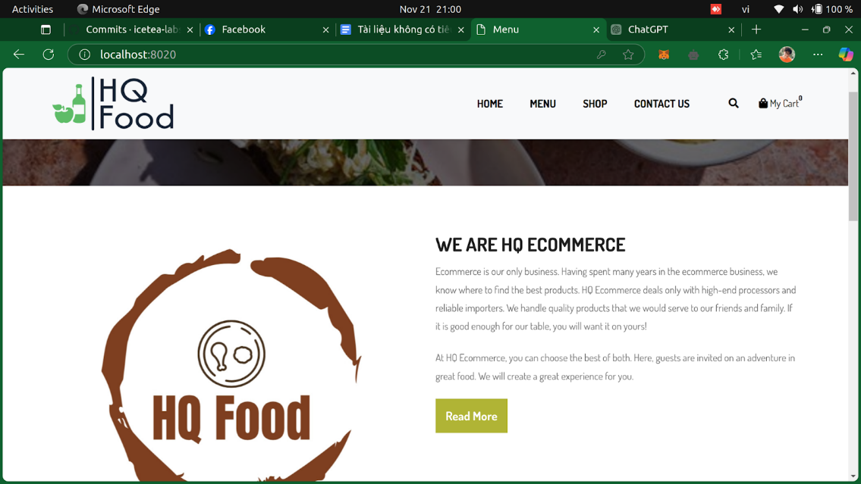

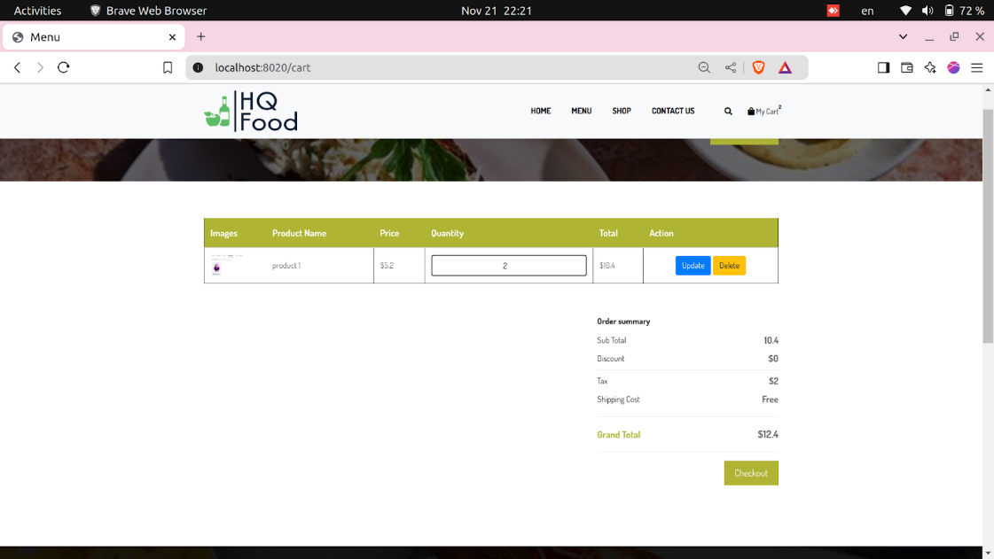

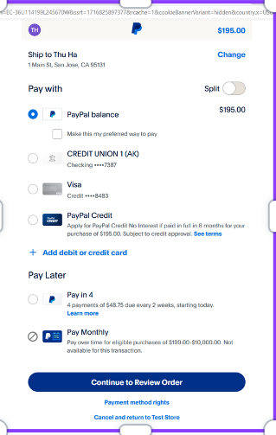

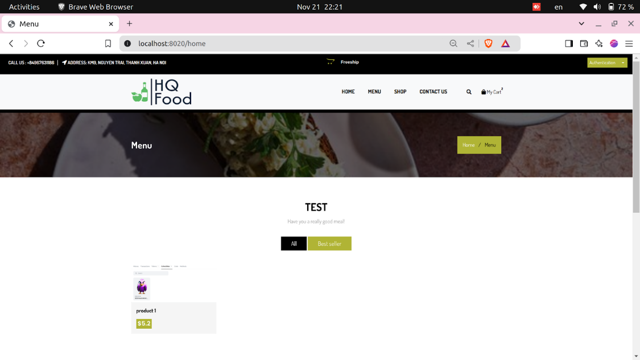

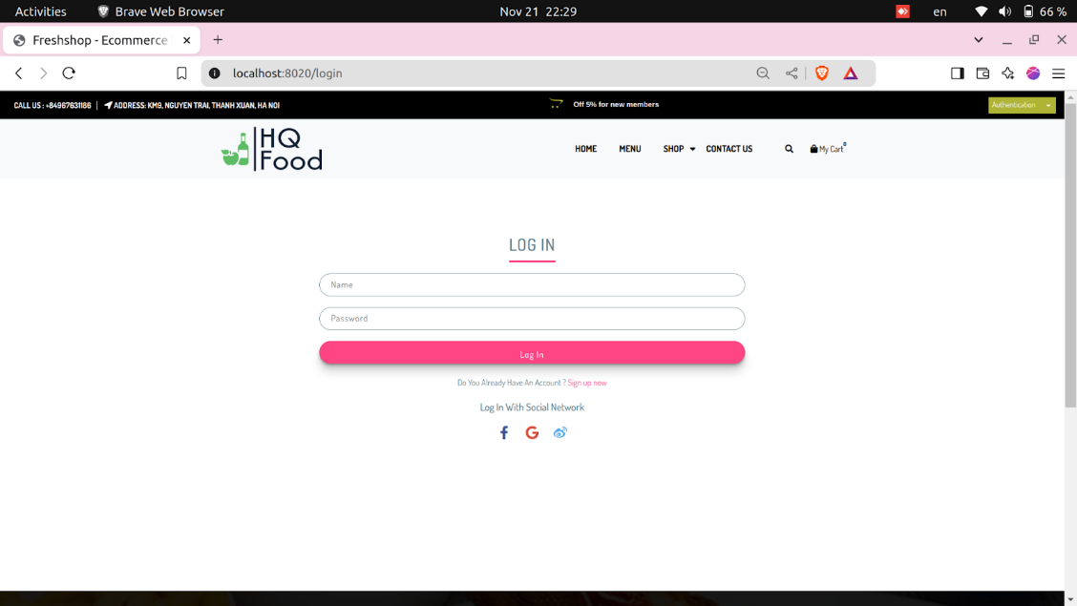

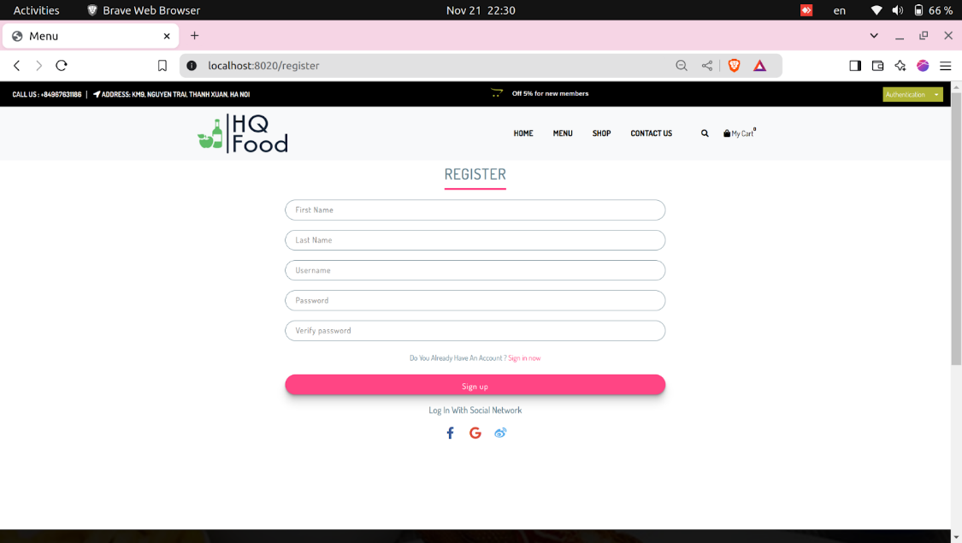

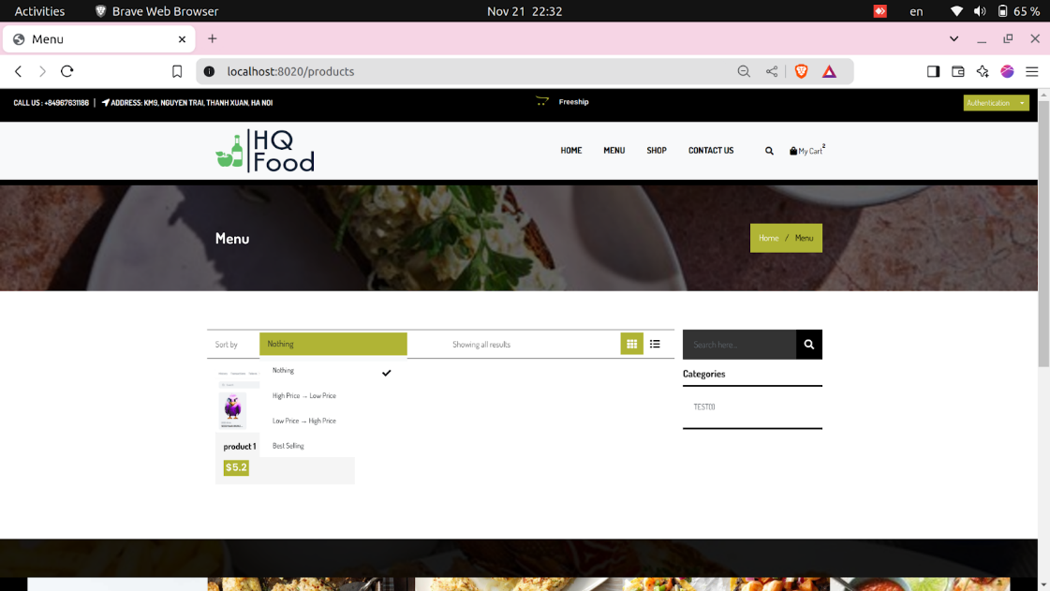

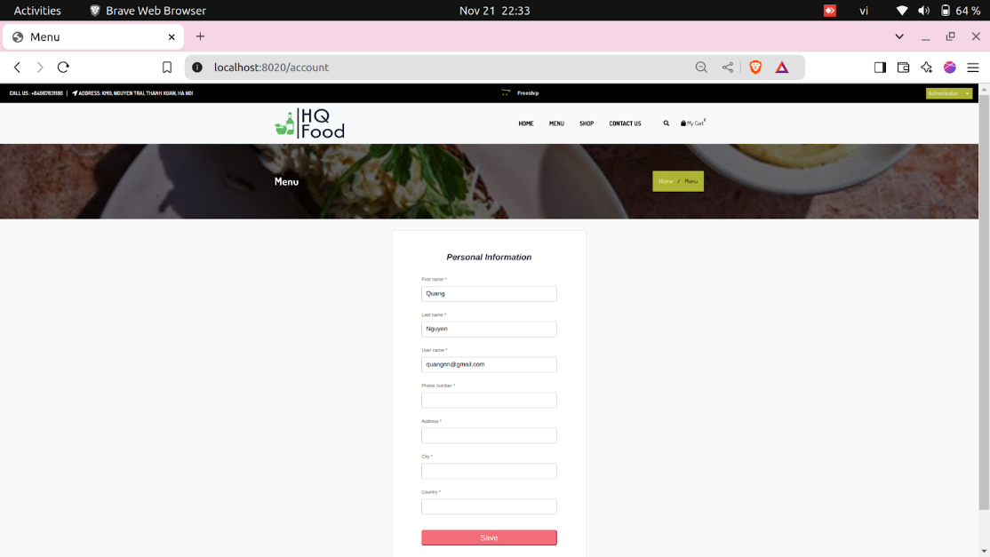

* + Admin

